AP Computer Science Principles

Teacher: Mr. Meserve Website: Canvas Email:smeserve@wcpss.net
Supplies Needed:
Teacher Availability:
Before School every day - 7:00 - 7:18
After School Tuesday– 2:20 – 3:20
Hawks Nest every day
- Notebook
- Pen or Pencil
- 2 Highlighters
- Flash Cards
- USB Drive
Course Description: CSP is designed to introduce students to the central ideas of computing and computer science, to instill ideas and practices of computational thinking. The course is rigorous and rich in computational content, critical thinking and skills, creative aspects of the computer science field, and how computer science affects the world. There is no designated programming language for this course and programming is a component of the course making up about 50% of the content taught. This course appeals to a broad audience and engages each student individually.
The course grade weights are as follows:
Units/ Modules | Projects | Assessments
Classwork, Homework, Vocabulary, Journal Entries, Research, Collaboration. | Creative projects at the beginning, middle, or end of each unit. | Quizzes
35% | 50% | 15%

All work for each Unit (10) will be locked after that Unit Exam has been attempted. No late work for that Unit will be accepted.

Absences, Tardies, and Make-up work: Attendance will be checked daily, and we will be adhering to the school policy regarding tardies and make up work. The student is responsible to check Canvas daily to view the work that was assigned

Students are encouraged to discuss classroom topics at home as well as show parents their projects, journals, research papers, and teacher feedback which can all be found on their Canvas accounts.

All website links are found in Canvas: Code.org. AP Computer Science Principles. College Board Digital Portfolio

Units and Overview | AP Computer Science Principles Standards Guide 2019
 | Big Idea 1:  Creativity | - Computational Thinking  - Computational Artifacts  - Intro to APCSP, Base 10, Base 2, Base 16  - Flowcharting  - Vocabulary Unit 1
 | Big Idea 2:  Abstraction | - Types of Abstraction (data, procedural)  - Snap! Programming  - Creating functions  - Vocabulary Unit 2
 | Big Idea 3:  Data and Information | - Evaluating sources and how to reference them  - Computing Innovations  - Privacy, storage, and security concerns with data management  - Legal and ethical issues related to data  - Vocabulary Unit 3
 | Big Idea 4:  Algorithms | - Flowcharting in depth  - Board Games (in-person and online)  - Creating a maze or trivia game using App Inventor  - Types of Algorithms (Sequencing, Selection, Iteration)  - Vocabulary Unit 4
 | Big Idea 5:  Programming | - Alice Programming  - Python Programming  - 1D Array Lists  - App Inventor  - Creating lists to manage data  - Creating guessing games, quizzes, mazes, and other interactive programs  - Vocabulary Unit 5
 | Big Idea 6:  The Internet | - Cybersecurity  - Cryptocurrency  - Models and Simulations  - IP Addresses  - Packets and Routers  - Vocabulary Unit 6
 | Big Idea 7:  Global Impact | - What is a computing innovation?  - How does the world use computing technology every day?  - Technology Innovation Exploration

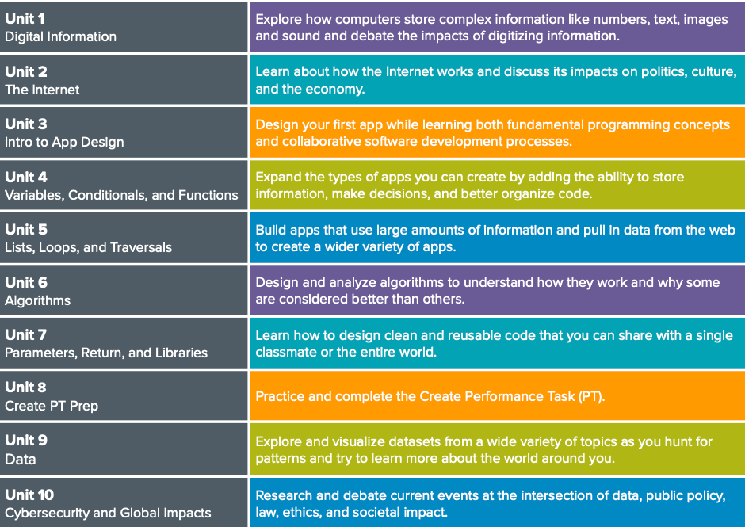

Return this portion of the syllabus to Mr. Meserve within the first week!
Signing below indicates that you AND your student have read the syllabus and acknowledge the policies outlined therein.

AP Computer Science Performance Task
Submitted by Monday May 1, 2023 by 11:59pm

AP Exam Monday May 8, 2023

Student Name (Print) __________________________________

Student Signature _______________________________________

Parent/Guardian (Print) ______________________________________

Parent/Guardian Signature ___________________________________
Parent/Guardian email ______________________________________
Date Signed: _____________________ Date Turned in:_____________

