Entrepreneurship I

Proof of Learning Guide

BUSINESS, FINANCE, AND MARKETING EDUCATION | Career and Technical Education


ME11 Entrepreneurship I Summer 2020 109
ME11 Entrepreneurship I Proof of Learning

OVERVIEW

Performance-based measurements (PBMs) when used as the proof of learning (POL) for a course gives teachers a tool to evaluate student achievement and mastery of course concepts. A PBM measures students' ability to apply the skills and knowledge learned from course standards. Typically, the task challenges students to use their higher-order thinking skills to create a product or complete a process (Chun, 2010).

PROOF OF LEARNING FOR ME11: ENTREPRENEURSHIP I

The course objective of Entrepreneurship I is to provide students with essential knowledge to prepare them for opening a small business that they are passionate about or that addresses a need in their community. Through design thinking, students will be asked to consider a business idea they will use throughout the course.

The course is structured around the Lean Canvas Business Model (LCBM), an industry accepted model. Students will complete the LCBM which covers the following key components: Problem, Customer Segments, Unique Value/Selling Proposition, Solution, Channels, Key Metrics, Revenue Streams, Cost Structure, and Competitive Advantage.

Students will complete the LCBM document for their business idea and pitch it at the end of the course. These two deliverables will become the performance-based measurement in which students will demonstrate proof of learning of the concepts covered. A final grade will be determined by the following breakdown: Written LCBM (40%) and Oral Presentation/Pitch of business idea (60%).

While being exposed to the components through curriculum content, students will receive continuous feedback from their teacher and will further develop their business idea through iterating multiple times. It is important for students to make changes based on teacher and peer feedback. The components of the LCBM will be interwoven into the curriculum as shown in the table below.

Component(s) | Objective
Problem, Solution | 2.01, 2.05
Unique Value/Selling Proposition, Competitive Advantage | 3.02
Customer | 3.03
Channels | 4.01
Cost Structure | 4.04
Revenue Streams | 5.03
Key Metrics | 5.04

Throughout this project, students and teachers will work together to intentionally develop soft skills-project management, research and analysis, collaboration, creativity, critical thinking and communication skills. Students will also be expected to consider ethical implications of their business idea.

ME11 Entrepreneurship I Summer 2020 110
COURSE PROFICIENCY

Proficiency for this course is a weighted score of 70 and above.

TEACHER INFORMATION

The responsibility of the teacher is to guide students through the business planning process using the Lean Canvas Business Model (LCBM). It is crucial for the teacher to facilitate learning through a continuous improvement process accomplished through feedback from the teacher, peers, and business and industry representatives, if possible. The instructions below outline guidelines for the teacher.

Part I: Lean Canvas Business Model (Written Component)

- Instruct students to decide on a business idea.

- Ideas should be generated during the design thinking process covered in 2.01.

- Review the LCBM before presenting to students to become familiar with the components of the model.

- Show students an example of the LCBM for Uber, Google, Facebook, etc. or create a LCBM with the class to solve a need in your community.

- Review the rubric to be used for the written component.

- Provide students with a copy of the LCBM and post-it notes to use during idea generation.

- As objectives are completed through the semester, instruct students to complete a rough draft of that section to be used in their LCBM.

- After all sections have been completed, instruct students to review the sections and make necessary changes to improve their LCBM.

- Facilitate peer reviews for students to provide feedback for each other on the LCBM and instruct students to make any additional changes to enhance their LCBM.

- If possible, seek assistance from business and industry to review the LCBM of the students.

- Assess the LCBM (written component) using the Lean Canvas Business Model Written Rubric.

- Best practice is for only the teacher to assess the written component and to complete prior to the oral presentation/pitch to allow time for students to modify information if needed.

ME11 Entrepreneurship I Summer 2020 111
Part II: Oral Presentation/Pitch

- To prepare for the oral presentation/pitch of their business idea, instruct students to review the rubric for the presentation.

- Provide instruction and resources to students on how to pitch their business using some of the following:

  - Internet resources for a good business pitch

    - https://www.entrepreneur.com/article/251311 13 Tips on Delivering a Pitch Investors Cannot Turn Down.

    - https://www.americanexpress.com/en-us/business/trends-and-insights/articles/12-easy-steps-to-a-perfect-pitch/ 12 Easy Steps to a Perfect Pitch

    - https://www.forbes.com/sites/mattsymonds/2013/10/24/7-tips-for-pitching-your-entrepreneurial-idea-whether-to-angels-or-sharks/#33dd0e7635a2 7 Tips for Pitching Your Entrepreneurial Idea Whether to Angels or Sharks.

  - Video resources for a good professional pitch

    - https://www.youtube.com/watch?v=P2LwuF7zn9c How to Start a Pitch or a Presentation.

    - https://www.youtube.com/watch?v=3TPb5FMkA8o How to Deliver a Great Pitch

    - https://www.youtube.com/watch?v=c4Q7sfJEDHo Jillian Mannus: How to Deliver a Perfect Pitch

- At the end of the semester, plan class periods for the formal business plan presentations. If feasible, one or two outside assessors should be involved in assessing the presentations (CDC, administrator, CIMC, business and industry representatives).

- As a best practice, if outside evaluators are utilized, set up a separate room for presentations (judges and the student presenting only) to eliminate inequities that could occur if students hear questions of the judges before they present.

- Allow 8-12 minutes for each presentation (5-7 minutes for pitch of business idea and 3-5 minutes for questions and answers).

ME11 Entrepreneurship I Summer 2020 112


ME11 Entrepreneurship I
PBM Accountability Form

Directions: Complete this form to verify that students enrolled in ME11 Entrepreneurship I have met or not met specific criteria to earn proficiency on the Performance-based Measurement (PBM). Refer to the Proof of Learning Guide for this course for details on course proficiency.

It is highly recommended that teachers keep a copy of all student records to verify PBM performance.

Teacher Name | School
Teacher Email | School District/PSU
CIMC Name | Date
Class Period | Semester and Year


Proficiency Status for ME11 Entrepreneurship I
 |  | Student Name |  |  | Met |  |  | Not
 |  | Student Name |  |  | Met |  |  | Met
 | 1)
 | 2)
 | 3)
 | 4)
 | 5)
 | 6)
 | 7)
 | 8)
 | 9)
 | 10)
 | 11)
 | 12)
 | 13)
 | 14)
 |  | ME11 Entrepreneurship I | Summer 2020 |  |  |  | 113

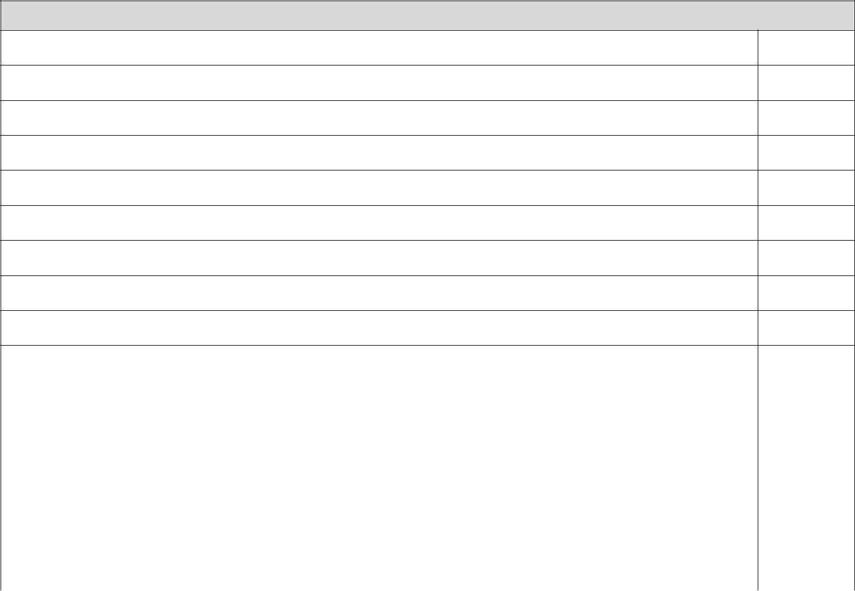
Proficiency Status for ME11 Entrepreneurship I

15)

16)

17)

18)

19)

20)

21)

22)

23)

24)

25)

26)

27)

28)

29)

30)

I, ____________________________________, verify that the students listed have met/not
Teacher Signature
met the proficiency as stated in the Proof of Learning Guide for this course. I have reported to my Curriculum and Instructional Management Coordinator (CIMC) the proficiency earned, as documented on this form, for the purpose of CTE reporting and accountability (state and federal).

This original form stays with the school’s CIMC. This original form and any copies are retained for five years.

ME11 Entrepreneurship I Summer 2020 114
STUDENT INFORMATION

Entrepreneurship I

Lean Canvas Business Model (LCBM) and Presentation/Pitch

As proof of learning for this course, you will be required to create a written Lean Canvas Business Model (LCBM) for a business idea of your choice and present/pitch the idea in a formal presentation at the end of the course. The written document will be weighted 40% and the pitch will be weighted 60%.

Part I: LCBM

Directions: Create a LCBM consisting of the following components:

- Problem – Description of the top problems the product/service is addressing (see objectives 2.01, 2.03, and 2.04).

- Customer segments - description of target customers (see objective 3.03).

- Unique value/selling proposition – description of the single, clear, compelling message that states the unique value/selling proposition and how you will promote to customers (see objective 3.02).

- Solution - Description of the top features of the product/service that solve the problem (see objective 2.05).
- Channels – Description of the pathways to customers (place) (see objective 4.01).

- Key metrics - Explanation of key activities that must be measured. (see objective 5.04)

- Revenue streams - Description of the revenue model and lifetime values. Price of product/service (see objectives 5.01, 5.02, and 5.03).

- Cost structure - Explanation of the marketing costs, distribution costs, human resource costs and any additional costs. (see objectives 4.03 and 4.04)

- Competitive advantage - Explanation of why the product/service cannot be easily copied or bought (see objective 3.02).

ME11 Entrepreneurship I Summer 2020 115
Entrepreneurship I Lean Canvas Business Model Rubric

TOTAL SCORE FOR LCBM WRITTEN COMPONENT line.
Student Name __________________________

DIRECTIONS: Circle the appropriate rating category for each of the ten components and enter a numerical score in the “Points Earned” column on the right. Provide comments on the page to help students understand strengths and areas for improvement prior to their oral

presentation/pitch. Total the “Points Earned” column and enter on the

 | Little/No Value | Below | Meets Expectations | Exceeds Expectations | Points
 | Little/No Value | Expectations | Meets Expectations | Exceeds Expectations | Earned
 |  | 1 or 2 problems | 3 problems are | 4 or more problems identified
 |  | are identified with | identified and | 4 or more problems identified
 | No problems | are identified with | identified and | and demonstrated
 | No problems | little demonstration | demonstrates | and demonstrated
Problem | identified. | little demonstration | demonstrates | exceptional use of the design
Problem | identified. | of the design | understanding of the | exceptional use of the design
 |  | of the design | understanding of the | thinking process.
 |  | thinking process. | design thinking process. | thinking process.
 | 0 | 1 | 2 | 3
 |  | Customer segment |  | Customer segments
 |  | Customer segment | Customer segments are | identified using
 | No customer | is identified but | Customer segments are | identified using
Customer | No customer | is identified but | identified and makes | demographic, geographic,
Customer | segments identified. | does not address | identified and makes | demographic, geographic,
Segments | segments identified. | does not address | sense for the problem. | psychographic, and
Segments |  | the problem. | sense for the problem. | psychographic, and
 |  | the problem. |  | behavioral segmentation.
 | 0 | 1 | 2 | 3
 |  | A selling |  | A selling proposition is
 | No unique selling | proposition is | A selling proposition is | A selling proposition is
Unique | No unique selling | proposition is | A selling proposition is | identified and is unique to
Unique | proposition is | identified but is not | identified and is unique | identified and is unique to
Value/Selling | proposition is | identified but is not | identified and is unique | the business. Data is used to
Value/Selling | identified. | unique to the | to the business. | the business. Data is used to
Proposition | identified. | unique to the | to the business. | support the position.
Proposition |  | business. |  | support the position.
 | 0 | 1 | 2 | 3
 |  | Solution listed for | Solutions are listed for | Several solutions are present
 |  | only one problem | Solutions are listed for | Several solutions are present
 |  | only one problem | each problem and | for each problem and
 |  | and little | each problem and | for each problem and
 | No solutions listed. | and little | demonstrates | demonstrates exceptional
Solution | No solutions listed. | demonstration of | demonstrates | demonstrates exceptional
Solution |  | demonstration of | understanding of the | understanding of the design
 |  | the design thinking | understanding of the | understanding of the design
 |  | the design thinking | design thinking process. | thinking process.
 |  | process. | design thinking process. | thinking process.
 | 0 | 1 | 2 | 3
ME11 Entrepreneurship I |  | Summer 2020 |  | 116

 | Channels of | Some potential | Potential channels of | Potential channels of
 | Channels of | channels of | Potential channels of | distribution have been
 | distribution not | channels of | distribution have been | distribution have been
Channels | distribution not | distribution have | distribution have been | identified and uses data to
Channels | listed. | distribution have | identified. | identified and uses data to
 | listed. | been identified. | identified. | support selected channels.
 | 0 | 1 | 2 | 3
 |  | Key metrics are |  | Key Metrics identified,
 |  | Key metrics are | Key Metrics identified | appropriate for the business,
 | No key metrics | identified but not | Key Metrics identified | appropriate for the business,
 | No key metrics | identified but not | and appropriate for the | and includes thorough
Key Metrics | identified. | appropriate for the | and appropriate for the | and includes thorough
Key Metrics | identified. | appropriate for the | business. | explanation of metrics
 |  | business. | business. | explanation of metrics
 |  | business. |  | chosen.
 | 0 | 1 | 2 | 3
 |  | Revenue streams | Revenue streams were | Revenue streams were
Revenue | No revenue streams | were identified but | identified and | identified, appropriate for the
Revenue | identified. | not appropriate for | appropriate for the | business, and includes
Streams
Streams |  | the business. | business. | supporting documentation.
 | 0 | 1 | 2 | 3
 |  | Cost structures | Cost structures have | Cost structures have been
 |  | have been | Cost structures have | identified, demonstrate
 |  | have been | been identified and | identified, demonstrate
 | Cost structures were | identified but | been identified and | understanding of
Cost | Cost structures were | identified but | demonstrate | understanding of
Cost | not identified. | inappropriate | demonstrate | fixed/variable costs, and
Structure | not identified. | inappropriate | understanding of | fixed/variable costs, and
Structure |  | understanding of | understanding of | include charts, graphs, or
 |  | understanding of | fixed/variable costs. | include charts, graphs, or
 |  | fixed/variable costs. | fixed/variable costs. | other visuals.
 | 0 | 1 | 2 | 3
 |  | A competitive | A competitive advantage | A competitive advantage is
 | No competitive | advantage is | A competitive advantage | identified, is appropriate for
 | No competitive | advantage is | has been identified and | identified, is appropriate for
Competitive | advantage | identified but not | has been identified and | the business, and evidence
Competitive | advantage | identified but not | is appropriate for the | the business, and evidence
Advantage | identified. | appropriate for the | is appropriate for the | of market research is
Advantage | identified. | appropriate for the | business. | of market research is
 |  | business. | business. | demonstrated.
 | 0 | 1 | 2 | 3
ME11 Entrepreneurship I |  | Summer 2020 |  | 117

Formatting | More than 10 errors | 6-10 errors in | 1-5 errors in formatting, | No errors in formatting,
Formatting | in formatting, | formatting, | 1-5 errors in formatting, | No errors in formatting,
Grammar | in formatting, | formatting, | grammar, or layout are | grammar, or layout are
Grammar | grammar, or layout | grammar, or layout | grammar, or layout are | grammar, or layout are
Layout | grammar, or layout | grammar, or layout | present. | present.
Layout | are present. | are present. | present. | present.
 | 0 | 1 | 2 | 3

TOTAL SCORE FOR LCBM WRITTEN COMPONENT____________

Comments: _________________________________________________________________________________________________________________

__________________________________________________________________________________________________________________________

__________________________________________________________________________________________________________________________

__________________________________________________________________________________________________________________________

__________________________________________________________________________________________________________________________

__________________________________________________________________________________________________________________________

ME11 Entrepreneurship I Summer 2020 118
Part II: Oral Presentation/Pitch

Directions: Prepare a pitch for your business idea based on the components of the LCBM you created and present to one or more qualified judges. Review the rubric for the required elements of the presentation/pitch. Your presentation should be 5-7 minutes long and must have an appealing visual. This can be a PPT, Prezi, tri-fold board, or other acceptable means of presenting your business idea (teacher approval required) or a combination of these items. Remember that you are pitching this business idea and seeking the approval of the judges. On presentation day, dress appropriately for your presentation/pitch, anticipate any questions you may be asked about your business idea, and be prepared to answer these questions.

You may use the resources below to help prepare for your presentation/pitch.

- Internet resources for a good business pitch

  - https://www.entrepreneur.com/article/251311 13 Tips on Delivering a Pitch Investors Cannot Turn Down.

  - https://www.americanexpress.com/en-us/business/trends-and-insights/articles/12-easy-steps-to-a-perfect-pitch/ 12 Easy Steps to a Perfect Pitch

  - https://www.forbes.com/sites/mattsymonds/2013/10/24/7-tips-for-pitching-your-entrepreneurial-idea-whether-to-angels-or-sharks/#33dd0e7635a2 7 Tips for Pitching Your Entrepreneurial Idea Whether to Angels or Sharks.

- Video resources for a good professional pitch

  - https://www.youtube.com/watch?v=P2LwuF7zn9c How to Start a Pitch or a Presentation.

  - https://www.youtube.com/watch?v=3TPb5FMkA8o How to Deliver a Great Pitch

  - https://www.youtube.com/watch?v=c4Q7sfJEDHo Jillian Mannus: How to Deliver a Perfect Pitch

ME11 Entrepreneurship I Summer 2020 119
ENTREPRENEURSHIP I ORAL PRESENTATION/PITCH RUBRIC

Student Name _____________________________

DIRECTIONS: Circle the appropriate rating category for each of the thirteen components and enter a final numerical score in the “Judged Score” column on the right. Total the “Judged Score”
column and enter on the TOTAL SCORE FOR ORAL PRESENTATION/PITCH line.
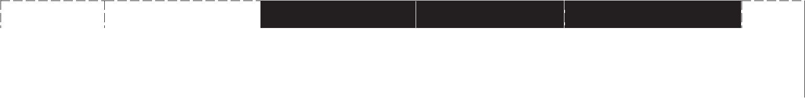

 |  | LITTLE/ NO VALUE
Introduction |  | No attention getter or
 |  | overview of business
 |  | idea was present.
 | 1
 |  | LITTLE/ NO VALUE
Problem |  | No description of the
 |  | problem was given.
 | 1
 |  | LITTLE/ NO VALUE
Customer |  | No customer segments
Segments |  | are identified or
 |  | described.
 | 1
 |  | LITTLE/ NO VALUE
Unique Value/ |  | No unique value
Selling |  | proposition was
Proposition |  | identified.


BELOW EXPECTATIONS
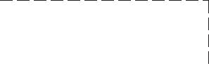
Overview of business idea but no attention-getter was present.
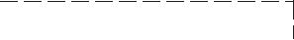
4


BELOW EXPECTATIONS
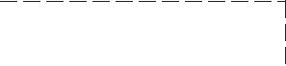
A description of one problem was given.
3


BELOW EXPECTATIONS
One customer segment was identified and described.
3
BELOW EXPECTATIONS
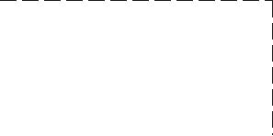
An attempt is made at stating a unique value proposition.
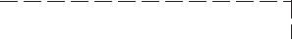

MEETS EXPECTATIONS
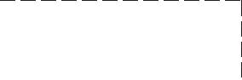
Attention-getter and overview of business idea was present.
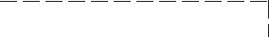
7

MEETS EXPECTATIONS
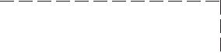
A description of two problems was given.
5

MEETS EXPECTATIONS
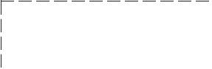
Two customer segments were identified and described.
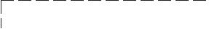
5

MEETS EXPECTATIONS
A single, clear, compelling message that states the unique value proposition was given.

EXCEEDS EXPECTATIONS | JUDGED
 | SCORE
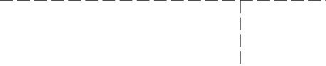
Creative attention-getter and extensive overview of business idea was present.
10
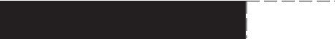
EXCEEDS EXPECTATIONS | JUDGED
 | SCORE
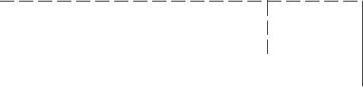
A description of three or more problems was given.
7
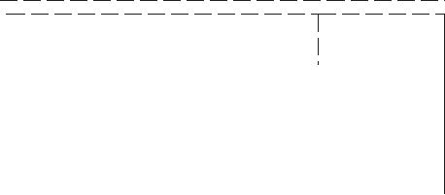
EXCEEDS EXPECTATIONS |  | JUDGED
 |  | SCORE
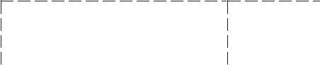
Three or more customer segments were identified and described.
7


EXCEEDS EXPECTATIONS | JUDGED
 | SCORE
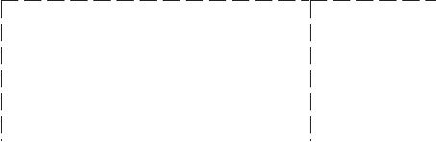
A single, clear, compelling message that states the unique value proposition was given and expanded upon.

1
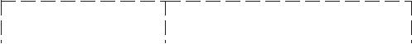
3

5 7
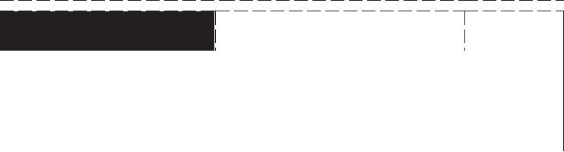

 |  | LITTLE/ NO VALUE
Solutions |  | No description to solve
 |  | the problem was given.
 | 1
 |  | LITTLE/ NO VALUE
Channels |  | No description of a
 |  | pathway to customers
 |  | was given.
 | 1
 |  | LITTLE/ NO VALUE
Key Metrics |  | No explanation of key
 |  | activities that must be
 |  | measured was given.
 | 1
 |  | LITTLE/ NO VALUE
Revenue |  | No description of the
Streams |  | revenue model was
 |  | given.
 | 1

BELOW EXPECTATIONS
A description of one solution to the problem was given.
3

BELOW EXPECTATIONS
A description of one pathway to customers was given.
3

BELOW EXPECTATIONS
An explanation of one key activity that must be measured was given.
3

BELOW EXPECTATIONS

A description of one part of the revenue model was given.

3
MEETS EXPECTATIONS
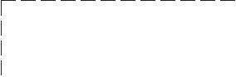
A description of two of the top solutions to the problem was given.
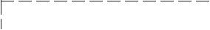
5

MEETS EXPECTATIONS
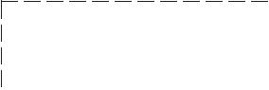
A description of two pathways to customers was given.
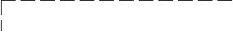
5

MEETS EXPECTATIONS
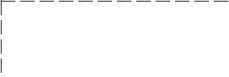
An explanation of two key activities that must be measured was given.
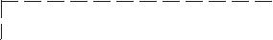
5

MEETS EXPECTATIONS
A description of two parts of the revenue model was given.
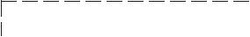

5

EXCEEDS EXPECTATIONS |  | JUDGED
 |  | SCORE
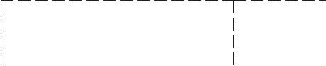
A description of three of more of the top solutions to the problem was given.
7
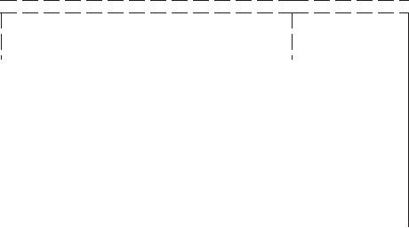
EXCEEDS EXPECTATIONS |  | JUDGED
 |  | SCORE
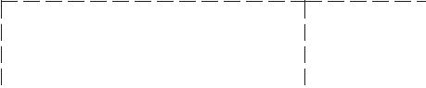
A description of three or more pathways to customers was given.
7
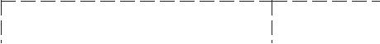
EXCEEDS EXPECTATIONS |  | JUDGED
 |  | SCORE
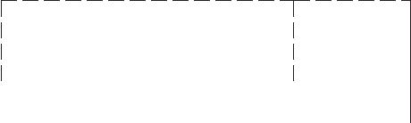
An explanation of three or more key activities that must be measured was given.
7
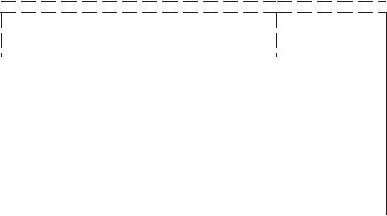
EXCEEDS EXPECTATIONS |  | JUDGED
 |  | SCORE
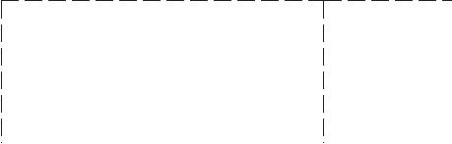
A description of three or more parts of the revenue model was given including an explanation of gross margin.
7

ME11 Entrepreneurship I Summer 2020 2


Cost

Structure
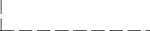


Competitive

Advantage


Conclusion


Visual

Presentation

LITTLE/ NO VALUE


No explanation of the following costs was given: customer acquisition costs, distribution costs, human resources costs, or other additional costs.
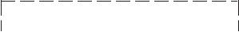
1


LITTLE/ NO VALUE
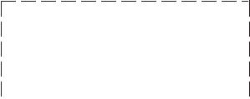
No explanation of why the product/service cannot be easily copied or bought was given.
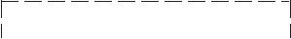
1


LITTLE/ NO VALUE
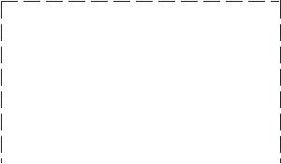
No specific request for financing was made.
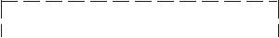

1
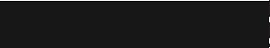
LITTLE/ NO VALUE

Presentation was not visually appealing, did not limit the number of bullets on slides, and had more than 10 spelling and grammar errors.
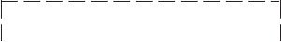
4

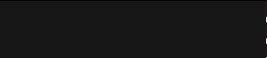
LITTLE/ NO VALUE
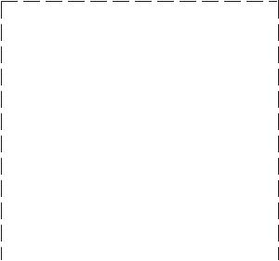
BELOW EXPECTATIONS

An explanation of one of the following costs was given: customer acquisition costs, distribution costs, human resources costs, or other additional costs.
3
BELOW EXPECTATIONS
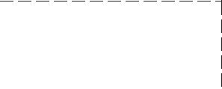
One explanation of why the product/service cannot be easily copied or bought was given.
3

BELOW EXPECTATIONS
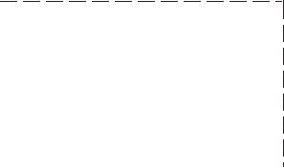
A request for financing was made but no key points supporting the financial request were presented.
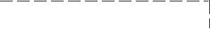

3

BELOW EXPECTATIONS

Presentation was not visually appealing, did not limit the number of bullets on slides, or had more than 5 spelling and grammar errors.
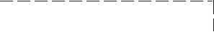
6

BELOW EXPECTATIONS
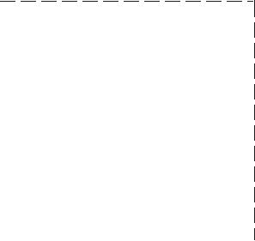
MEETS EXPECTATIONS

An explanation of two of the following costs was given: customer acquisition costs, distribution costs, human resources costs, or other additional costs.
5

MEETS EXPECTATIONS
Two explanations of why the product/service cannot be easily copied or bought was given.
5

MEETS EXPECTATIONS
A specific request for financing was made and a summary of two key points supporting the financial request was presented.
5
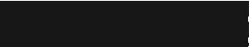
MEETS EXPECTATIONS
Presentation was visually appealing with an appropriate theme, limited number of bullets on slides, and had two or less spelling and grammar errors.
8
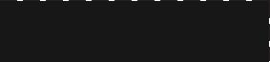
MEETS

EXPECTATIONS
EXCEEDS EXPECTATIONS |  | JUDGED
 |  | SCORE

An explanation of all of the following costs was given: customer acquisition costs, distribution costs, human resources costs, or other additional costs.

7
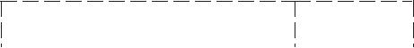
 | EXCEEDS EXPECTATIONS |  | JUDGED
 |  |  | SCORE
 | Three explanations of why
 | the product/service cannot
 | be easily copied or bought
 | was given.
7
 | EXCEEDS EXPECTATIONS |  | JUDGED
 |  |  | SCORE
 | A specific request for
 | financing was made and a
 | summary of 3 or more key
 | points supporting the
 | financial request was
 | presented.
7
 | EXCEEDS EXPECTATIONS |  | JUDGED
 |  |  | SCORE
 | All components were
 | covered, presentation was
 | visually appealing with an
 | appropriate theme, limited
 | number of bullets on slides,
 | and had no spelling or
 | grammar errors.

10
EXCEEDS EXPECTATIONS |  | JUDGED
 |  | SCORE


Oral

Presentation
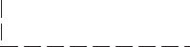
Appropriate dress, eye contact, volume, and pacing were not evident. Presentation did not meet tie requirement of 5-7 minutes. Student did not answer questions effectively.
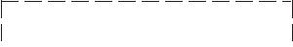

4
Only one of the following were demonstrated:
- appropriate dress, eye contact, volume, and pacing were evident

- presentation met the requirement of 5-7 minutes

- student answered questions effectively.
6
Two of the following All of the following were

were demonstrated: demonstrated:

1. appropriate dress, eye 1. appropriate dress, eye
contact, volume, and contact, volume, and pacing

pacing were evident were evident

2. presentation met the 2. presentation met the
requirement of 5-7 requirement of 5-7 minutes

minutes 3. student answered

3. student answered questions effectively.
questions effectively.
8 10

TOTAL SCORE FOR ORAL PRESENTATION/PITCH _________

ME11 Entrepreneurship I Summer 2020 3

Student Name __________________________

ME11 Entrepreneurship I Proof of Learning Final Score Calculation Sheet

 | Score from Rubric | % | Weighted Score
TOTAL SCORE FOR LCBM WRITTEN COMPONENT |  | 40
TOTAL SCORE FOR ORAL PRESENTATION/PITCH |  | 60
FINAL SCORE FOR PBM

FINAL COMMENTS/FEEDBACK FOR STUDENTS

__________________________________________________________________________________

__________________________________________________________________________________

__________________________________________________________________________________

__________________________________________________________________________________

__________________________________________________________________________________

__________________________________________________________________________________

__________________________________________________________________________________

ME11 Entrepreneurship I Summer 2020 4

