“Design the Ideal Wallet [Online Version]”

Length: ~90 Minutes
If your class sessions are 50 - 75 minutes long, consider doing this across two sessions.

Author: Stanford University d.school

Introduction
This exercise from Stanford University’s d.school is a fast-paced group activity to introduce your students to design thinking. Students get the feel of a design approach, gain some shared vocabulary, and get a taste of each design "mode" (empathize, define, ideate, prototype, test). Specifically, students learn the value of engaging with real people to help them ground their design decisions, that low-resolutions prototypes are useful to learn from (take an iterative approach), and to bias toward action (you can make a lot of progress in a little bit of time if you start DOing).

Resources
Here is an intro video that explains a bit about facilitating a design thinking exercise, and then some guidance for this particular exercise.

Here is the Wallet Exercise Facilitator’s Guide.

Here are the worksheets to send your students to print. If students cannot print worksheets, you can use your video conferencing platform to demonstrate how they can use blank sheets to recreate these worksheets.

Before Class
Let students know that they should come to class with as many of the following items as they can.

- Cardboard, blank paper, and/or Post-It notes
- Scissors or a utility knife
- Tape, paper clips or a stapler
- String or rubber bands
- Markers or colored pens
- Anything else you want to suggest

Note: Not all students will have access to the same supplies, and that this might create some inequity in experiencing this activity. We encourage you to create a large list of the possible supplies your particular student population may have access to. Encourage students to worry less about getting the exact items in the list, and more about getting resourceful and creative about finding potential building supplies.

The goal is for students to have some supplies readily available to create a makeshift prototype.

The Activity

Educator Guide |  | Time (Min) | Suggestions
Step 1: The Wrong Approach | Tell students:  “Instead of just telling you about design thinking, we want to immediately have you jump right in and experience it for yourself. We are going to do a design project for about the next hour. Ready? Let’s go!”  Direct students to the “Design the IDEAL wallet” worksheet if they have printed this ahead of time.  Don’t give students any instructions here - just tell them to draw an idea for their ideal wallet in 3 minutes.  Remind students after each minute expires. After the 3 minutes expires, ask students:  “How did that feel?”  They will likely offer some emotions that are not that positive. Highlight those, and tell them “that was a typical problem-solving approach, taking on a given problem, working using your own opinions and experience to guide you, and with a solution in mind to be designed. Let’s try something else - a human-centered design thinking approach.” | 0-10 | It’s important to remind students that you are not a good artist (whether you are or are not), and that they are not going to be judged at all by their artistic ability.  If students have not printed the worksheets, tell them at each step to get out a blank sheet of paper and recreate the particular worksheet while you share it on your screen.  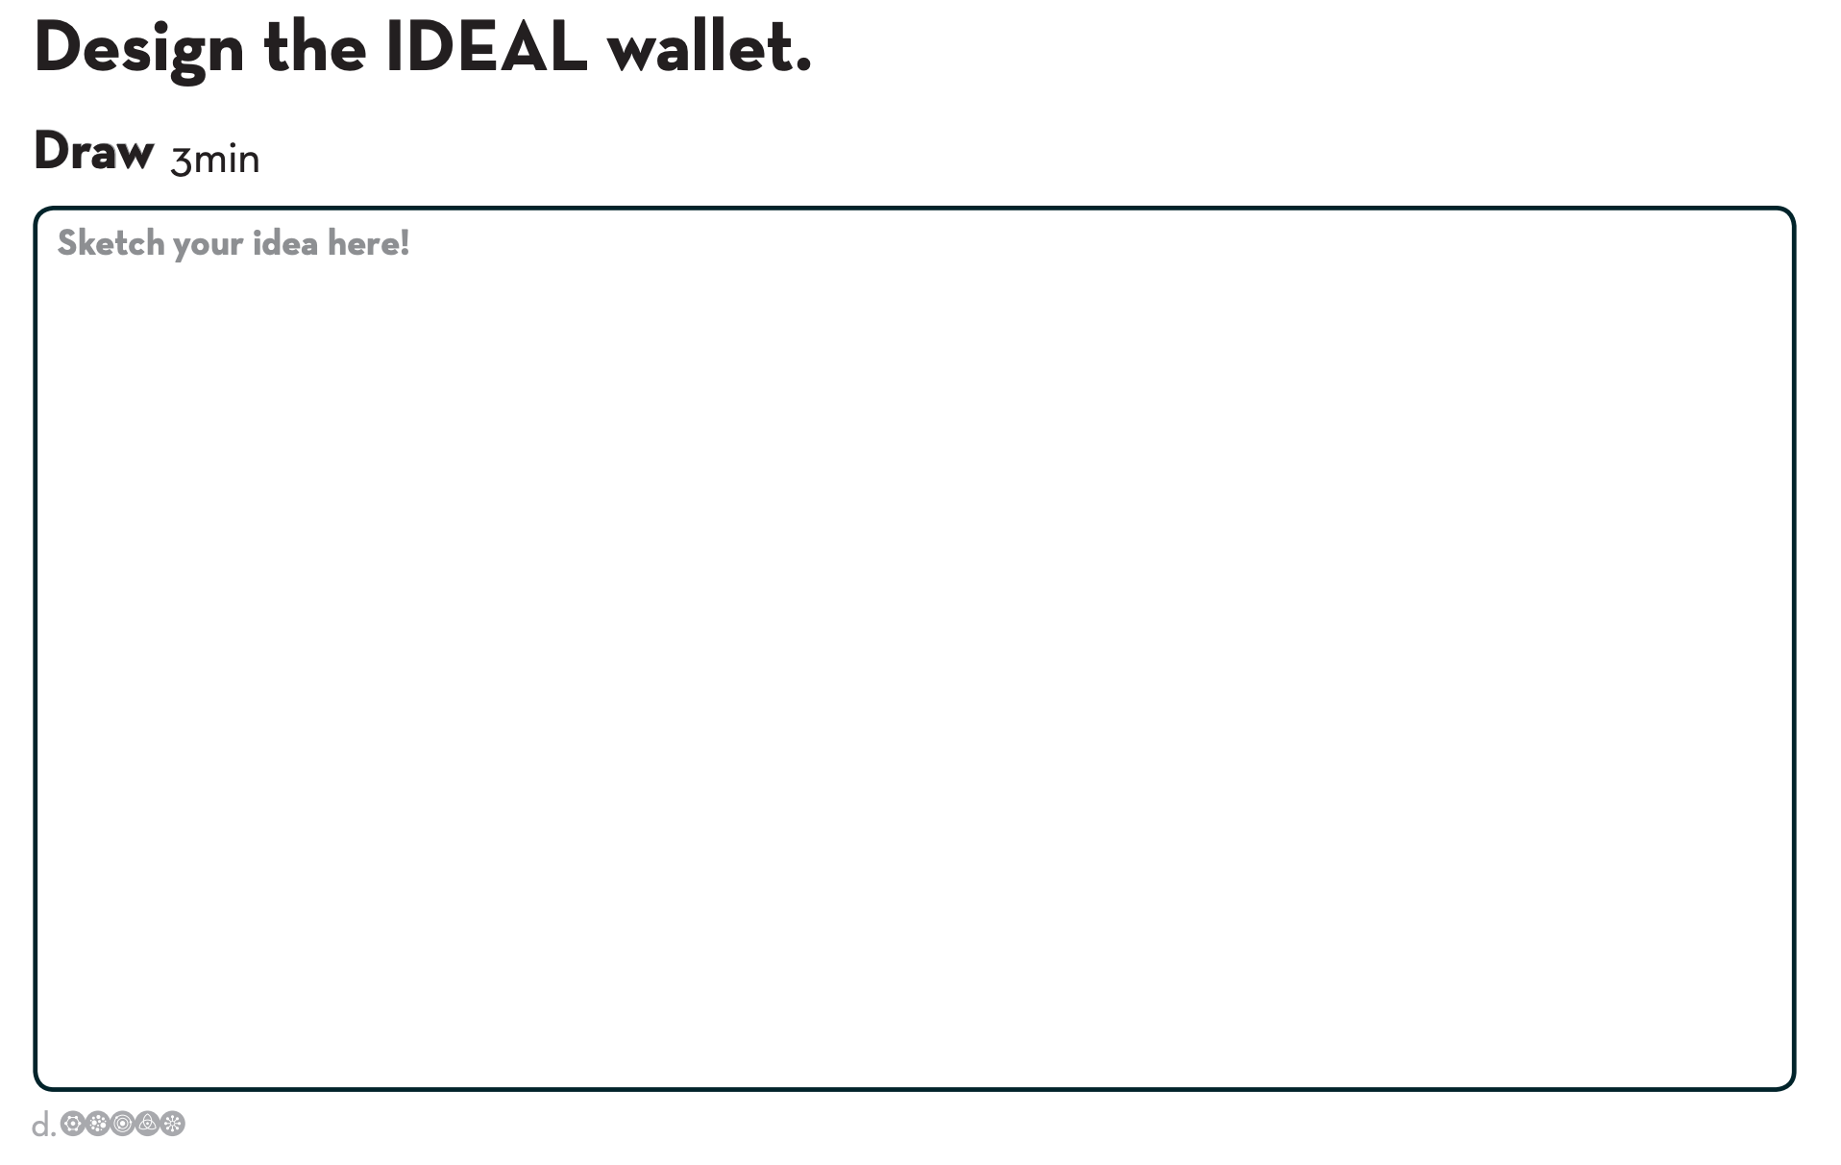
Step 2: A Better Approach | Have students pull out the “Your New Mission” worksheet if they printed it, or to create the worksheet on a blank sheet of paper if they have not.  Let them know you will send them into breakout rooms in pairs to design something useful for their partner.  Partner A has 4 minutes to interview Partner B, then they switch. Partner A walks Partner B through the contents of Partner B’s wallet. Partner A makes notes in the “Interview” column of their worksheet.  Then they switch and spend 4 minutes in reversed roles. | 11-20 | 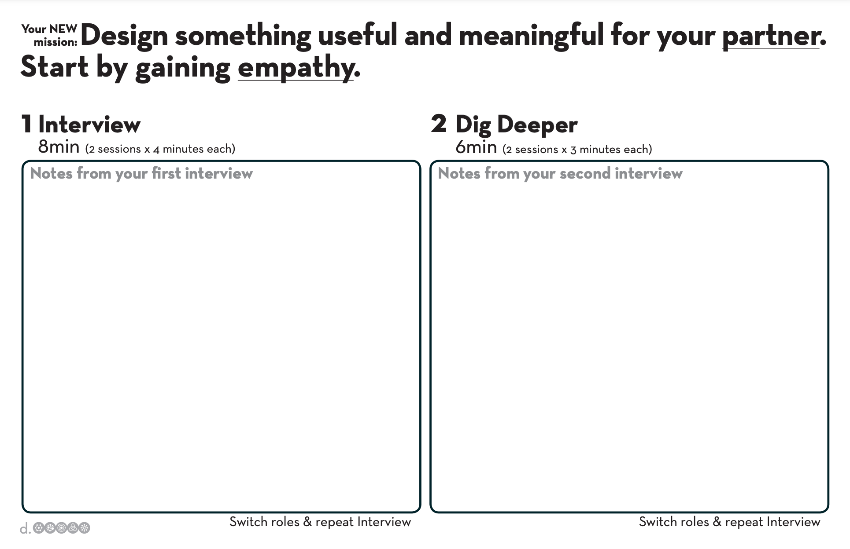  Tell students the most important part of designing for someone is to gain empathy. Students will do this through having a conversation with their partner.  Encourage Partner A to ask questions about when they carry a wallet, why they have particular things in there, and to make notes of things they find interesting or surprising.
Step 3: Dig Deeper | Encourage students to follow up on things they found interesting or surprising from their Step 2 interviews. They should dig for stories, feelings and emotions (around pictures, artifacts, etc.)  Encourage students to ask “Why?” often and to let their partner talk. Remind students to make note of any unexpected discoveries and to capture quotes. | 21-30 | Students need to understand that the wallet is a distraction, that what is important for them to discover is what is important to their partner.
Step 4: Reframe the Problem | Have students pull out the “Reframe the Problem” worksheet if they printed it, or to create the worksheet on a blank sheet of paper if they have not.  Set a timer for 3 minutes. Each student should reflect on what they learned about their partner. Tell students to synthesize their learning into two groups:  - Their partner’s goals and wishes. Students should use verbs to express these. Remind students that these should be needs related to the wallet and life, that they should think about physical and emotional needs. Give them an example of maybe their partner needing to minimize the number of things he carries, or he needs to feel like he is supporting the local community and economy.  - Any insights they discovered. Tell them they can leverage insights when creating solutions. Give them an example that they might discover their partner values purchases more when using cash to make it. Another example could be that the partner sees the wallet as a reminder and organizing system, not a carrying device. | 30-36 | 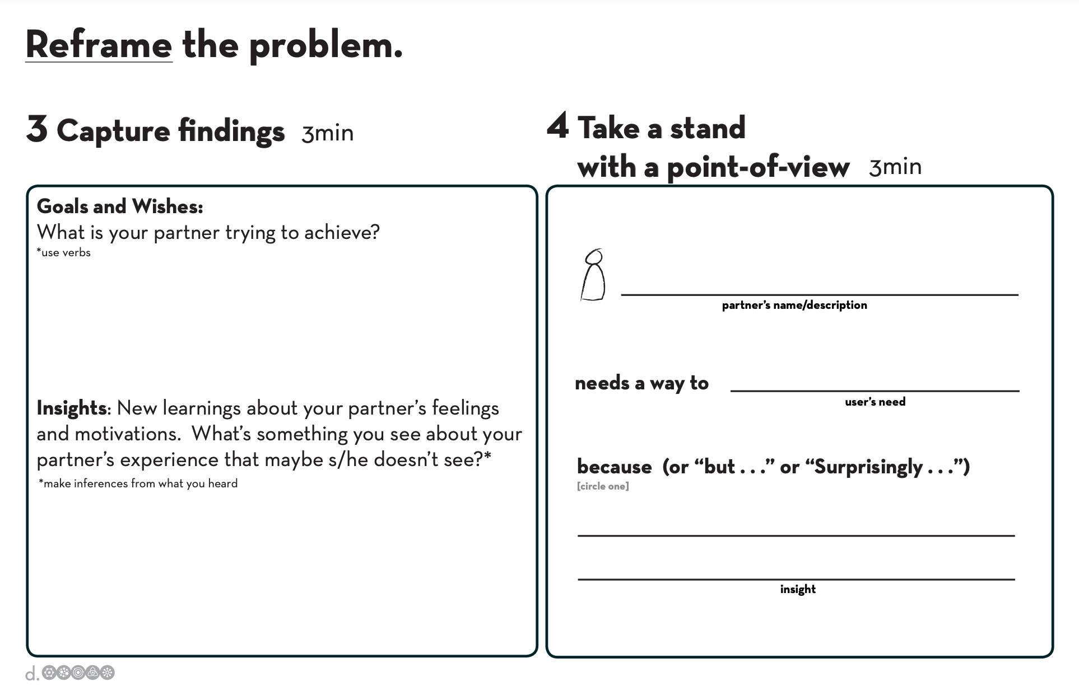
Step 5: Take a Stand | Students continue to use the “Reframe the Problem” worksheet if they printed it, or to create the worksheet on a blank sheet of paper if they have not.  In the “Take a Stand” column, students take 3 minutes to select the most compelling need and most interesting insight they gained from their partner. This statement is going to be the foundation for their design work, so encourage them to make it actionable, and exciting. Give them an example like these:  “Janice needs a way to feel she has access to all her stuff and is ready to act. Surprisingly, carrying her purse makes her feel less ready to act, not more.”  or  “Arthur needs a way to socialize with his friends while eating healthy, but he feels he isn’t participating if he isn’t holding a drink.” | 36-39 | This is where students articulate their point-of-view around which they will build solutions.
Step 6: Sketch to Ideate | Have students pull out the “Ideate” worksheet if they printed it, or to create the worksheet on a blank sheet of paper if they have not.  At the top, students write their problem statement from Step 5. Tell them they have 5 minutes to create solutions to the challenge they’ve identified.  Push them that quantity is better than quality here, that they should go for volume of sketches of ideas. | 40-45 | Keep telling students as each minute passes, and remind them to be visual, to not use words but to use pictures.  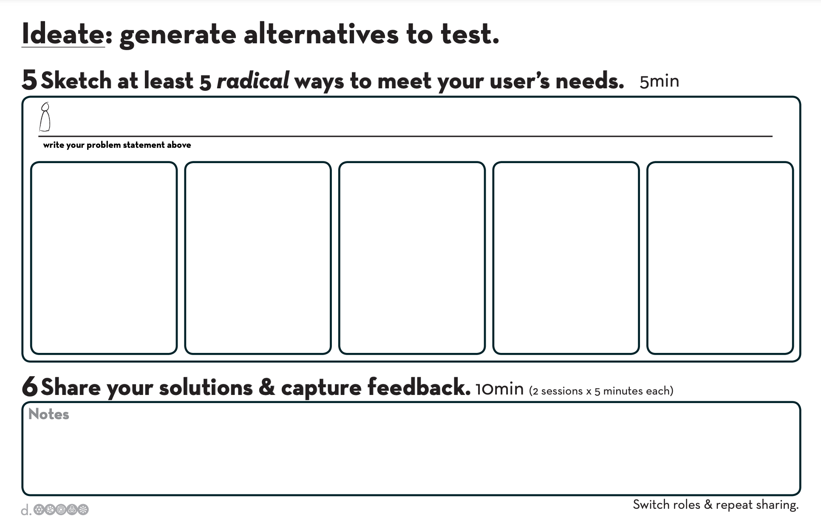  Remind students the goal here is idea generation, not evaluation; challenge them by saying “see if you can come up with at least 7 ideas!”
Step 7: Share Solutions & Capture Feedback | Students continue to use their “Ideate” worksheet.  Send students into breakout rooms in the partner pairs you previously used. Partners share their sketches from Step 6 with each other for 5 minutes each.  As each partner gives reactions to the sketches, the other partner should take note of any likes and dislikes, and also listen for any new insights. After four minutes, students switch. | 45-55 | Remind students the goal here is not to validate their ideas, and not to explain or defend their idea. This is an opportunity to learn more about their partner’s feelings and motivations.
Step 8: Reflect & Generate New Solutions | Have students pull out the “Iterate based on feedback” worksheet if they printed it, or to create the worksheet on a blank sheet of paper if they have not.  Using all they’ve learned thus far, students have 3 minutes to sketch a new idea. This idea can be a variation on an idea from before, or could be something entirely new. It is OK if they need to adjust their problem statement to incorporate new insights and needs they discovered in Step 7. | 56-60 | Encourage students to provide as much detail and color around their idea as they can. They should think about how the solution fits into their partner’s life, when and how they might handle or encounter the new solution.  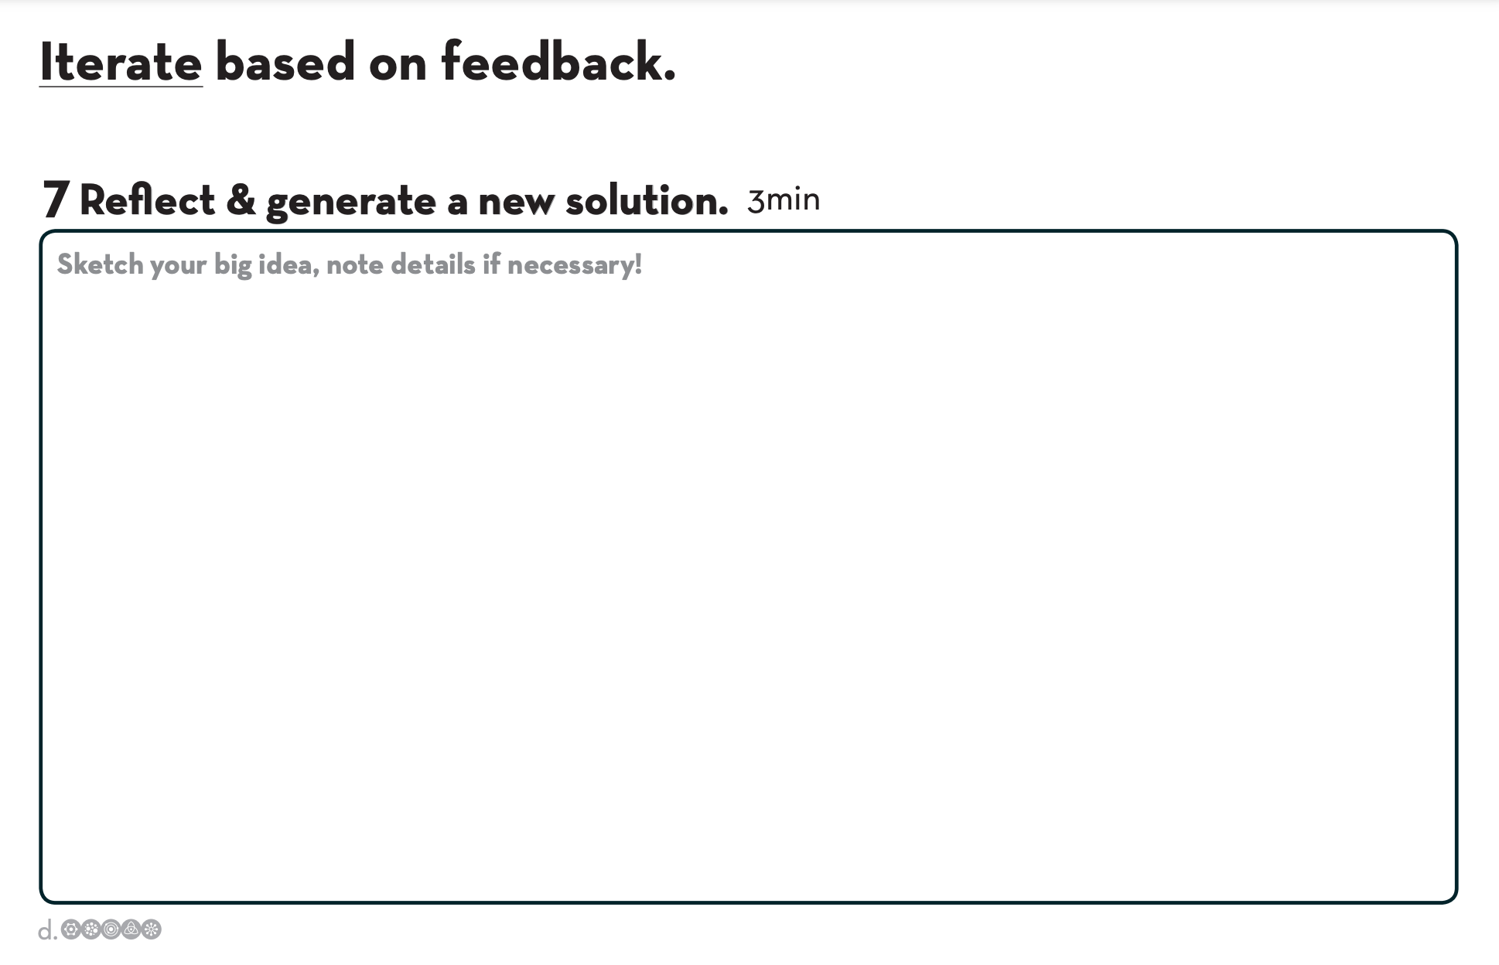
Step 9: Build! | Have students pull out the “Build and test” worksheet if they printed it, or to create the worksheet on a blank sheet of paper if they have not.  Tell students they have 7 minutes to create a physical prototype of their solution using the household supplies that gathered before class. They need to actually make something their partner can physically see and imagine engaging with. | 60-68 | 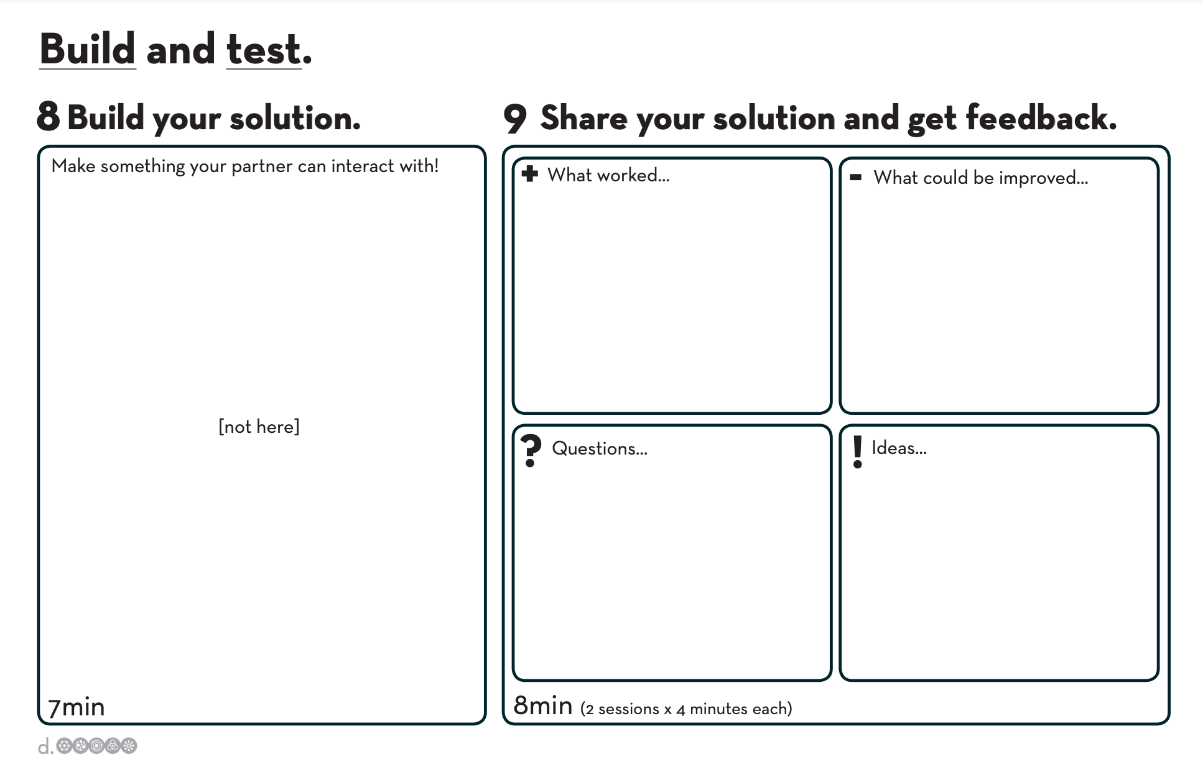  Explain they should not just make a scale model of their idea.  Students who want to create a service will ask how they can create that. Talk about creating a scenario that allows someone to experience it - they can use space, act it out, etc.  Push students to be quick, remind them they have only a few minutes.
Step 10: Share Your Solution and Get Feedback | Students continue using the “Build and test” worksheet if they printed it, or to create the worksheet on a blank sheet of paper if they have not.  One partner shares their prototype with the other partner for 4 minutes and collects feedback, then partners will switch roles for another 4 minutes. They should take note of what their partner liked and didn’t like, what questions and ideas emerged. | 69-77 | Tell students they are only interested in a targeted conversation around the experience, specifically focused on their feelings and emotions.
Step 11: Group Gather & Debrief | Ask students:  - “Who had a partner who created something that you really like?”  - “Who sees something they are curious to learn more about?”  When a student is curious about a prototype, ask for the person who created the prototype and engage them in the conversation:  - “How did talking to your partner inform your design?”  - “How did testing and getting feedback impact your final design?”  - “What was the most challenging part of the process for you?” | 78-90 | This step is important! A well facilitated reflection has the power to turn this exercise from simply a fun activity to a meaningful experience that could impact the way participants approach innovation in the future.  The key to leading this conversation is to relate the activity to the following takeaways:  - Human-centered design: Empathy for the person or people you are designing for, and feedback from users, is fundamental to good design.  - Experimentation and prototyping: Prototyping is an integral part of your innovation process. A bias towards action, toward doing and making over thinking and meeting.  - Show don’t tell: Communicate your vision in an impactful and meaningful way by creating experiences and interactive visuals.  - Power of iteration: Learn, try, fail, learn more, try again, fail again, learn more, and so the cycle goes. A person’s fluency with design thinking is a function of cycles, so we challenge participants to go through as many cycles as possible—interview twice, sketch twice, and test with your partner twice. Additionally, iterating solutions many times within a project is key to successful outcomes.

Key Takeaway for Educators

This exercise is an immersive activity meant to give students a full cycle through the design thinking process in as short a time as possible. The project itself gives professors the opportunity to touch on human-centered design, a bias towards action, and a culture of iteration and rapid prototyping.

