DIRECTIONS TO THE INSTRUCTOR FOR GROUP ACTIVITY 2

Preparation: Duplicate the handout Famous Channels on page 2—one per student.
Process: Divide the class into groups of three or four students each. Explain that the groups are to complete the diagrams for consumer and industrial goods and for services. They are to identify two products that would be distributed through each type of channel. They should write their responses on the handouts in the spaces provided. When all the groups have completed the activity, the groups should compare and discuss their responses. An answer guide for the diagrams is in a separate document. Responses for product identification should be evaluated by the instructor.

FAMOUS CHANNELS

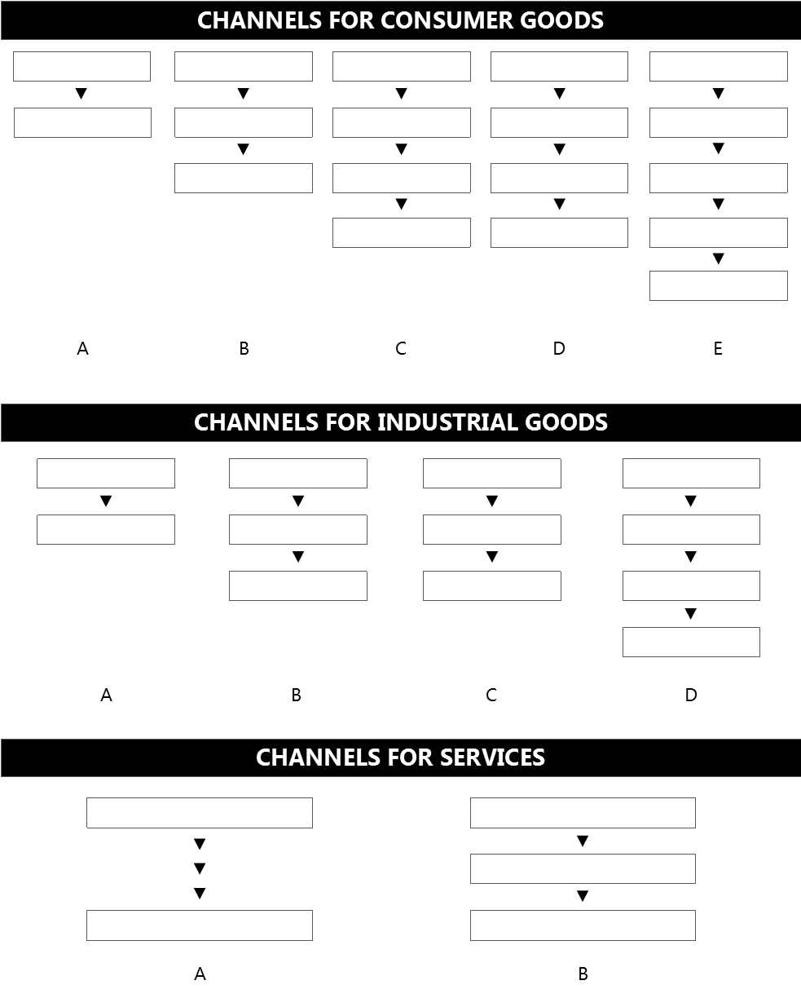
Directions: Complete the following channel diagrams for consumer and industrial goods and for services by writing the name of each channel member in the appropriate box. Below each type of channel, identify two products that would use the channel.

