How Have Prices For Consumer Goods Changed Over the Past 20 Years?

Data Crunch
Budgeting #6

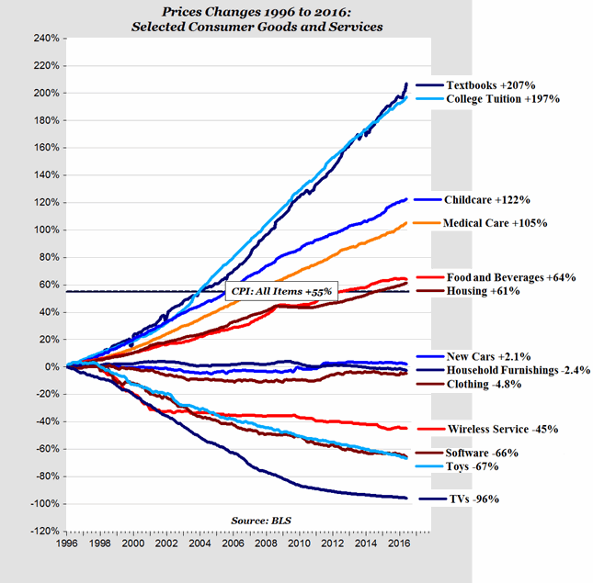 | - Which item has increased the most in price? Decreased the most in price?  INCREASED:  DECREASED:  DOK 1
- According to the graph, what items are priced within 5% of their original prices in 1996?

DOK 1
- How would you classify the industries in which the prices of items have increased and decreased the most?

INCREASED:

DECREASED:

DOK 2

- Look at how this graph is constructed. Assess why the publishers of this graph chose NOT to place 0% (the starting point in 1996) at the center of the graph.

DOK 3
- Hypothesize why prices of items like Wireless Service, Software, and TVs decreased so dramatically between 1996-2016.

DOK 3

