6.01 Accounting Scavenger Hunt
Directions: Use the picture links at the top of each section of questions to take you to a website where you will find the answers to the questions below it. DO NOT COPY AND PASTE ANSWERS!!
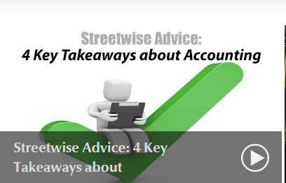
- Every month you should calculate how profitable your business is by filling out these two financial documents:

- Maybe you’re not good at accounting or even if you have a poor understanding of it, the main thing that you can do is keep your financial records ?
  - Give two examples why

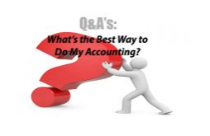
- What does accounting tell a business?

- What happens to a business if they don’t do any accounting?

- What’s more important for a business, income statements or balance sheets?

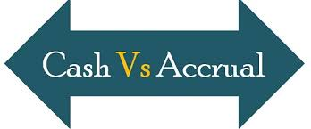
- In your words, describe the cash method of accounting:

- In your words, describe the accrual method of accounting:

- Which method (cash or accrual) do you think is the best and why?

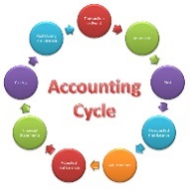
- In your own words, list the 15 steps of the accounting cycle

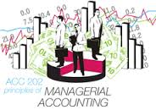
- In your own words, what is included in managerial accounting?

- What 3 accounting practices have been developed in the last decades?

- Who usually coordinates the accounting procedures in a business?

- What do the initials GAAP stand for? What does GAAP mean and why is it important?

- What are the 3 types of accounting?

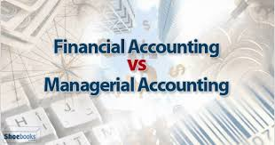
- Accounting is often called the of business.

- If you were going to invest (buy stock) in a company, would you rather look at their financial accounting records or their managerial accounting records? Why?

- What are the governing bodies that offer authority/guidance on each type of accounting method?

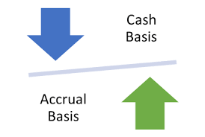
- In your own words, describe the 4 reasons why most businesses prefer the accrual basis of accounting?

