Math 2 Honors Fall 2020 Final Exam Review Name:

- For each picture shown below, classify the transformation as a translation, rotation, reflection, or dilation. Then, write the rule that describes the transformation.

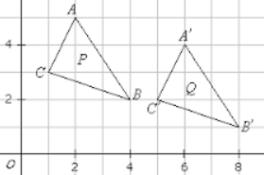 | 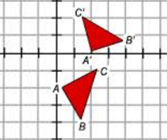
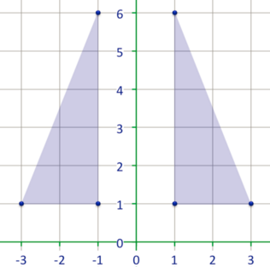 | 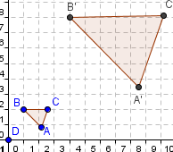

- Which of the following transformations does not result in a congruent figure?

(a) dilation (c) reflection

(b) rotation (d) translation

- Which pair of triangles is congruent by ASA?

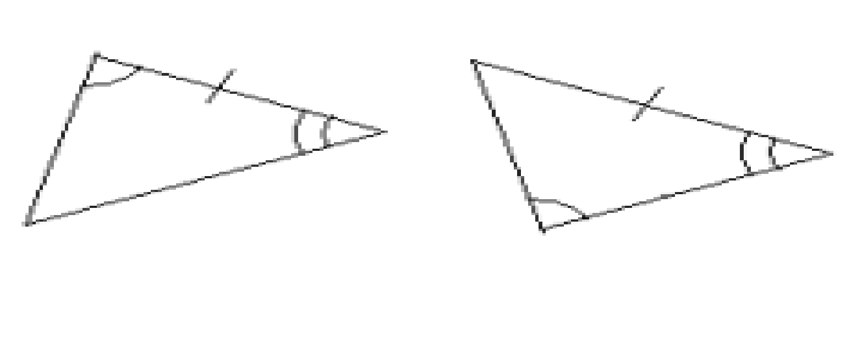
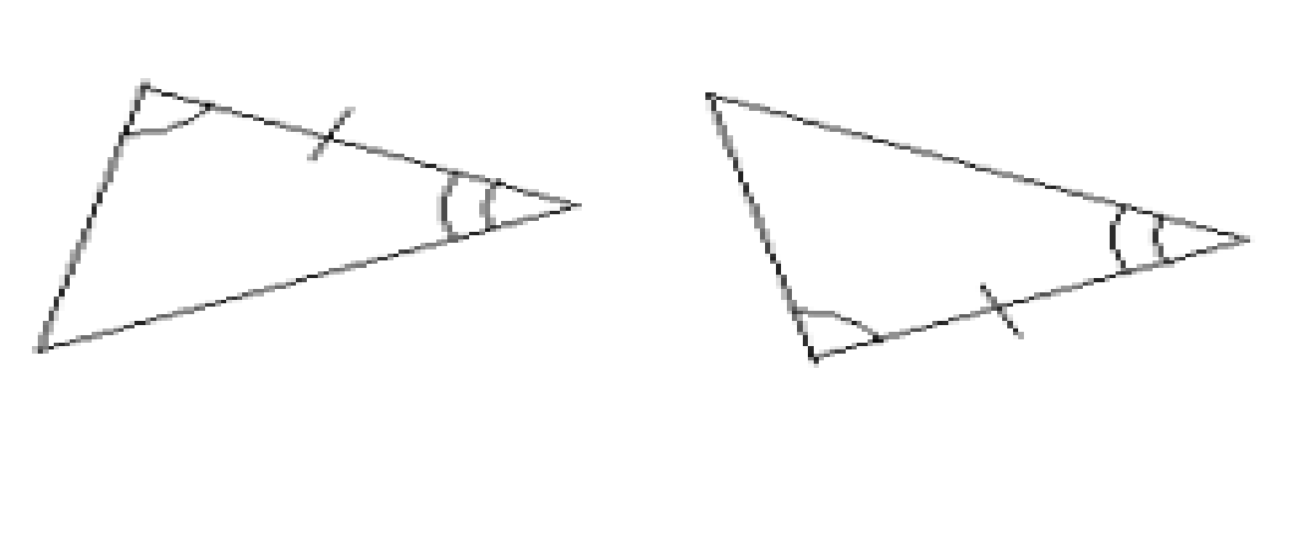
A . B.

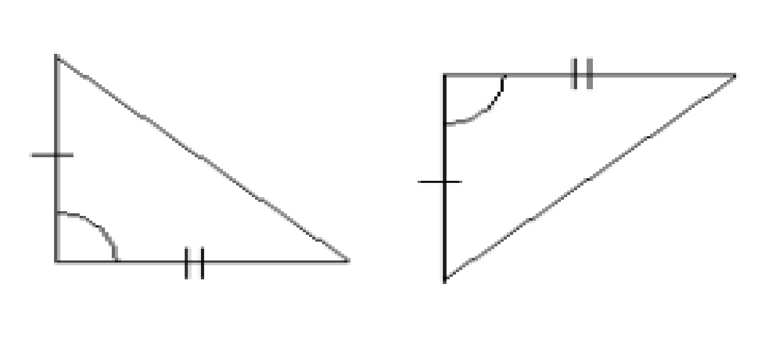
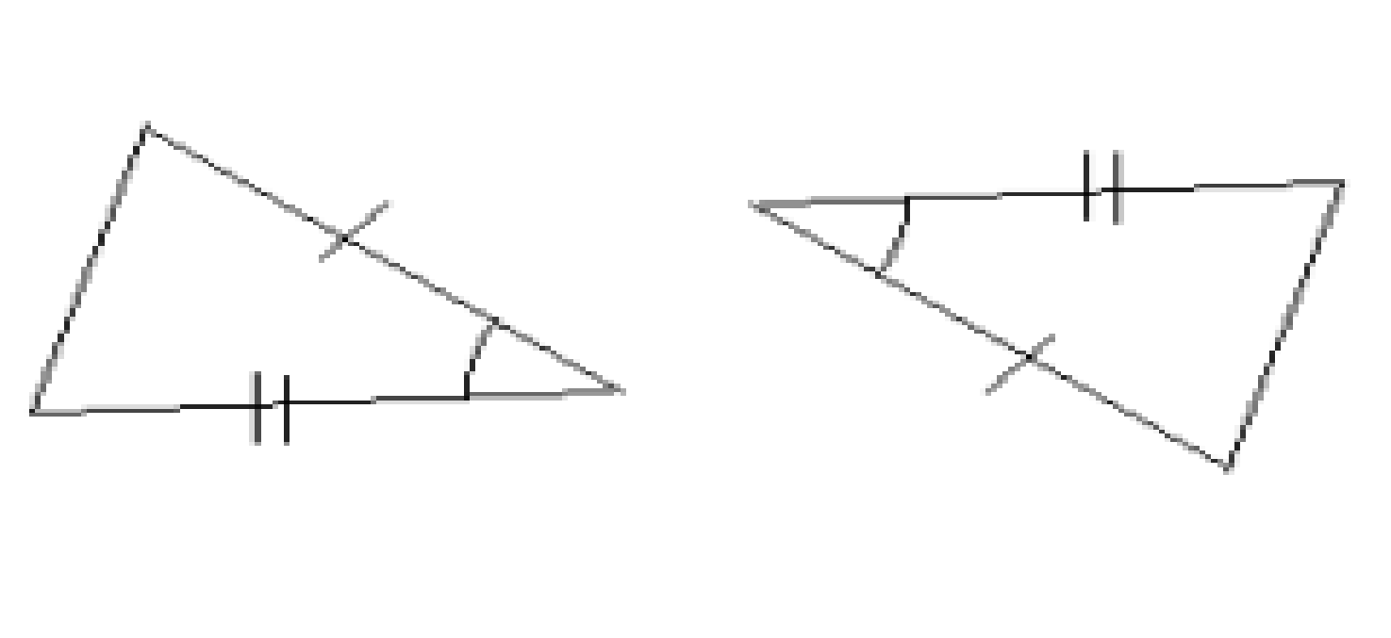
C. D.

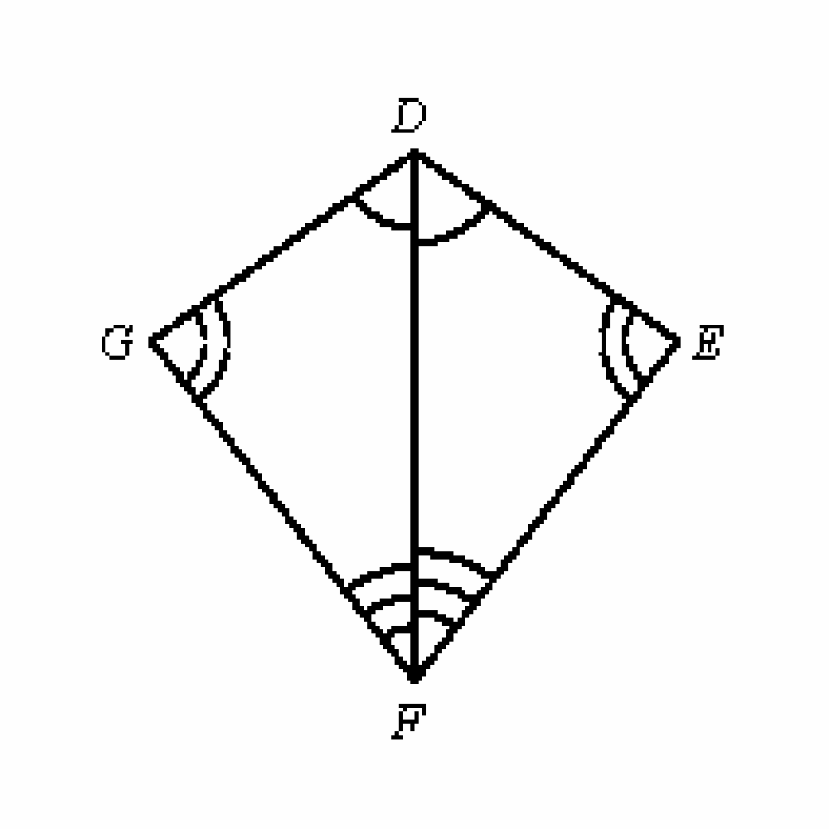
- By which of the following postulates could you say the triangles below are congruent?

A. SAS B. ASA C. SSS D. Not congruent

- What is the value of x in the figure below?
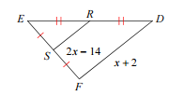

- Given $∆REI≅∆LUV, m∠I=2x+9,$and $m∠V=4x-5$, find $m∠I$.

- Describe the transformation of $y= {(x-7)}^{2}+4$ from the parent graph of $y=x^{2}.$

- Write the equation of the graph that results if the parent function $y=x^{2}$ is shifted down 9 units and left 6 units.

- Write the quadratic function that has x-intercepts at (-5,0) and (3,0) with a maximum at (-1,32)

- Write the quadratic function with x-intercepts at (-3,0) and (3,0) with a y-intercept at (0, 9).

- The height, h, in feet of an object above the ground is given by $h={-16t}^{2}+64t+190$ ,where t is the time in seconds. Find the maximum height of the object and the time it takes the object to hit the ground.

- Factor the following expressions.
- $x^{2} – 2x – 8$  - $x^{2}+9x+18$ | - $2x^{2} +7x-30$  - 8x² - 12x – 20

- Use the quadratic formula to solve ${3x}^{2}+11x+5=0$

- What are the zeroes of the function $f\left(x\right)=x^{2}-x-12$?
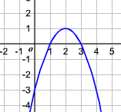

- For the following graph, label the axis of
symmetry, the vertex, and the x-intercepts.

Simplify each of the following.

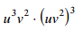 | 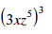
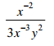 | 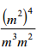

- Simplify the radical
$\sqrt[3]{27m^{6}n^{15}}$

- Solve each equation.

- $x^{2}-5=44$ b. $20=\sqrt{x^{4}}-5$

- What is the percent increase or decrease that $y=500(.94)^{x }$models?

- 94% increase  - 94% decrease | - 6% increase  - 6% decrease

- A car is bought for $16,000 in 2010. The car decreases in value by 4% each year.

- Write a function that represents the value of the car after t years.

- In 2020, how much will the car be worth?

- Graph each of the following functions.

- $y=\sqrt{x-4}+1$

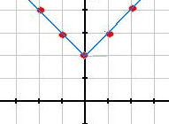
- What are the domain and range of
the graphed function, $y=\left|x\right|+2$?

- The time it takes Jay to get to his grandmother’s house varies inversely as his driving speed. Averaging 20 miles per hour in bad traffic, it takes him 1.5 hours to get to his grandmother’s. How long would the trip take if he averaged 50 miles per hour?

- Find the value of the missing side or angle in each of the problems below.

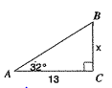 | 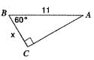
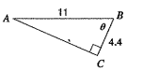 | 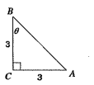

- A wooden beam 24 feet long leans against a wall and makes an angle of 71° with the ground. How high up the wall does the beam reach?

- After takeoff, a plane flies in a straight line for a distance of 4000 feet in order to gain an altitude of 800 feet. Find the angle of elevation from the ground to the plane.

- Find the measure of the angle of elevation of the sun when a vertical post 15 feet tall casts a shadow 20 feet long.

