Computer Programming 1
Indicator Apply Operators and Boolean Expressions. (3%)
In all programs, put your name, the assignment name and the date in comments at the top.
Reminder, put an apostrophe (‘) in front of your line to make it a comment.
- Create a new project called Math
  - Add the controls shown on the form below. Name them appropriately
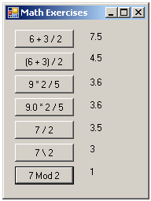

  - Using formulas, display the answers for each equation in a label in the button clicks.
- Create a new project called Mints
  - Add the following controls (You can use 2 or 4 labels for the answers)
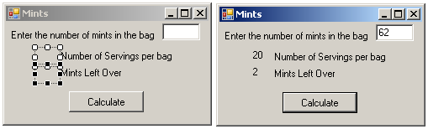
- For the btnShowMints control, create a Click event.
    - Declare variables needed for input and output
      - Total number of mints, Servings per bag and Mints LeftOver
      - Students eat 3 mints per serving
    - Get the input from your textbox using the Convert method to convert to an Int32 (Integer)
    - Calculate the servings and mints left over using Integer and Modulus division
    - Display the answer in your answer labels.
      - Don’t forget to use ToString

