Computer Programming 1
Essential Standard 6.03 Apply Procedures for Validation of User Input
Programming Exercise
In all programs, put your name, the assignment name and the date in comments at the top.
Reminder, put an apostrophe (‘) in front of your line to make it a comment.
- Create a project called CandyJar. Add the controls shown on the form below. Name appropriately.
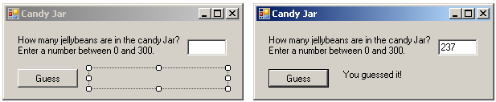
  - When the button is clicked, use an If statement with TryParse to validate that a number was entered.
    - If a number was entered, convert your values and use an if statement to tell the user if it was too high, too low or correct.
      - Hint: You will have a nested If statement.
    - If a number was not entered, display a MessageBox asking for numeric input.
- Create a project called CostCalculator. Add the controls shown on the form below. Name appropriately.
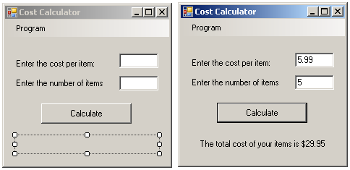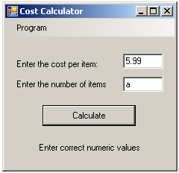
  - When the button is clicked, use TryParse in a compound if statement to validate input.
    - If the input is valid, convert the values and calculate the cost and display the answer formatted for dollars.
    - If the input is not valid, display an appropriate message in the label.

