Computer Programming I
Essential Standard 6.00 Apply tools to obtain and validate user input.
Indicator 6.02 Apply Procedures to Develop Message, Input, and Dialog Boxes. (3%)

Message, Input, and Dialog Boxes

- Message, input and dialog boxes increase the interactivity of your application.
- They allows the user to interface with your application.
- In this presentation we will look at how to add these new control objects to your application.

The MessageBox Control

- The MessageBox is a predefined dialog box that displays information to the user.
- The following code demonstrates how to use the Show method of the MessageBox class to display a message to the user.
Private Sub btnMsgBox_Click(ByVal sender As System.Object,
ByVal e As System.EventArgs) Handles btnMsgBox.Click
MessageBox.Show("This is the text in the MessageBox")
End Sub
- You can display a message box to request information.
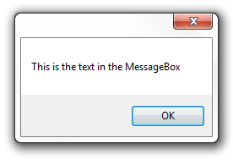
- There are options available with the MessageBoxButtons that allow you to offer to the user more options.
MessageBoxButtons.AbortRetryIgnore
MessageBoxButtons.OK
MessageBoxButtons.OKCancel
MessageBoxButtons.RetryCancel
MessageBoxButtons.YesNo
MessageBoxButtons.YesNoCancel
- You can compare the user’s choice with the DialogResult.
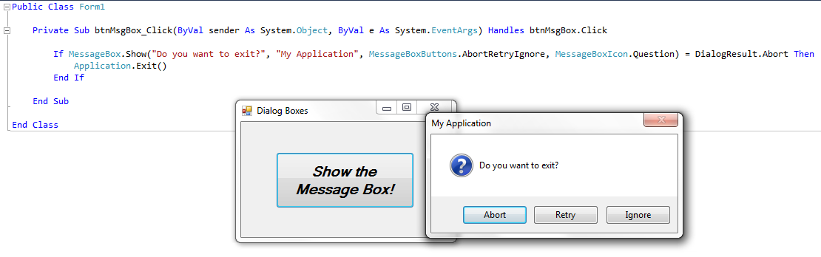
The InputBox Function

- The input box is a function that allows a user to input information.
- It displays a prompt in a dialog box, waits for the user to either hit the enter key or click a button, then returns the information from the textbox as a string.
- There is one required parameter, the Prompt. You will need to add a prompt that will be displayed at the top of the dialog box.
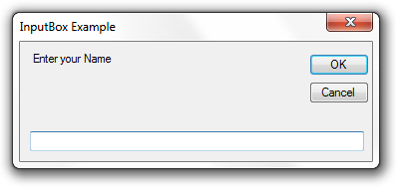
- The Title parameter, while set up with a default of nothing, should be set. The title is displayed in the title bar at the top of the dialog box.
Prompt
Title

- Note that there are additional optional parameters.
  - XPos, YPos
    - These set the position where the input box will be displayed.
- This example sets the result of the input box to the string variable strAnswer.
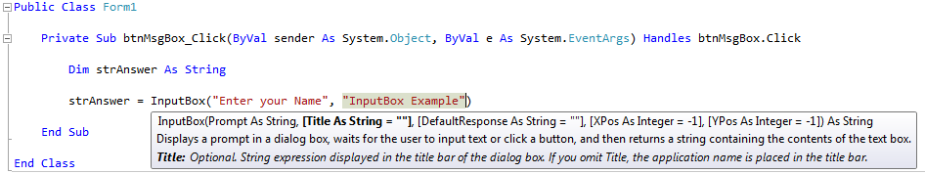
- Don’t forget that the input box returns a STRING. If you want to turn this value into a numeric value you will need to use the Val() function.
- Creating a Dialog Box
- Dialog boxes are used to get information from the user.
- You can create your own dialog box by adding a new Windows Form to your application.
- When you create a dialog box, you need to know it’s “result”.
  - For example, did the user click “OK” or “Close”.
- From the form that displays the dialog box, you can use the DialogResult property to determine which button was clicked.
- You can also set the DialogResult property if no buttons are used.

Creating a Dialog Box

- Steps to add a programmer defined dialog box
- From the Solution Explorer, right-click on your project, select add, then Windows Form.
Or you can go to the Project menu, select Add Windows Form, then Windows Form.
- Name the Form (otherwise it will be Form2 if it will be the second form, otherwise it will be Form3, etc).
- Your new form will be displayed in the Design Window.
- In the Properties window,
  - Change the FormBorderStyle property to FixedDialog.
  - Set the ControlBox, MinimizeBox, and MaximizeBox to false
- Customize your form.

Using a Dialog Box

- You can use the show and hide your new dialog box using the following commands.
- To show the dialog box
formName.Show()
- To hide the dialog box
formName.Hide()
- To close the dialog box
formName.Close()

For more information on this topic
- http://msdn.microsoft.com/en-us/library/2chz8edb(v=VS.80).aspx

For more information on Dialog Boxes
- http://msdn.microsoft.com/en-us/library/2chz8edb.aspx

