Computer Programming 1
Essential Standard 8.03 Apply Animation and Graphic Methods in a Windows Form
In all programs, put your name, the assignment name and the date in comments at the top.
Reminder, put an apostrophe (‘) in front of your line to make it a comment.
- Create a project called Kicks. Add controls for a Timer and a PictureBox, named appropriately.
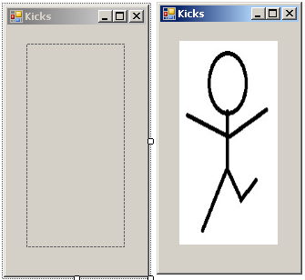
  - Timer
    - Enabled = true
    - Interval = 500
  - PictureBox
    - Add the images
    - Select “none” as the image showing.
  - Timer Tick
    - Add the code to change the image in the Tick event.
- Create a project called Talk. Add the controls named appropriately.
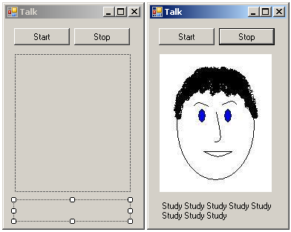
  - When the Start button is clicked, the timer should start.
  - When the Stop button is clicked, the timer should stop.
  - The timer should make your images change so that it looks like the face is “talking” as well as add “Study” to the label.
- Create a project called Me. Add the controls named appropriately.
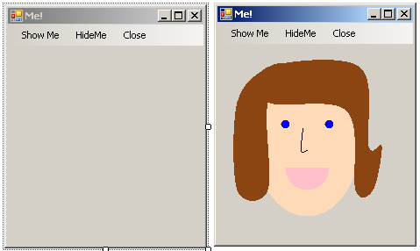
  - Set the form as the drawing surface
  - Main Menu
    - Show Me
      - Should draw a self-portrait
    - Hide Me
      - Should clear the surface
    - Close
      - Should close your application
- Create a project called Ship. Add the controls named appropriately.
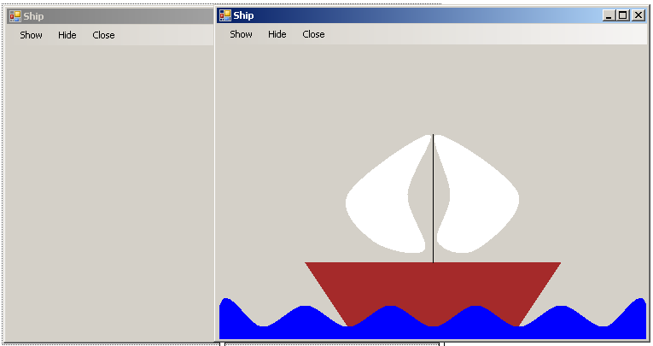
  - Set the form as the drawing surface
  - Main Menu
    - Show
      - Should draw a ship
    - Hide
      - Should clear the surface
    - Close
      - Should close your application

