Computer Programming 1
Essential Standard 6.01 Apply procedures to develop menus, List Box and Combo Box objects
Programming Exercises
In all programs, put your name, the assignment name and the date in comments at the top.
Reminder, put an apostrophe (‘) in front of your line to make it a comment.
- Create a new project called ColorChanger. The purpose of this program is to allow the user to choose options on a menu and have the form’s color change.
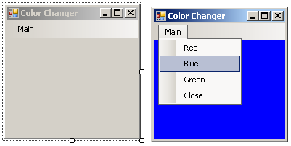
  - Add a menu to the form with the options of Blue, Green, Red and Close
  - Create a Click event for the Red menu option.
    - Add the following code
Me.Backcolor = Color.Red ‘This statement changes the background color to Red
  - Create a Click event for the Blue menu option.
    - Add the following code
Me.Backcolor = Color.Blue ‘This statement changes the background color to Blue
  - Create a Click event for the Green menu option.
    - Add the following code
Me.Backcolor = Color.Green ‘This statement changes the background color to Green
  - Create a Click event for the Close menu option.
    - Add the code to close the application.
- Create a new project called Bands. The purpose of this program is to select different bands from a menu to have that band’s information displayed. When the Close option is chose, it should close the application.
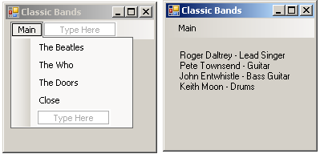
  - Add the MenuStrip item to your form by clicking on it in the ToolBox, then clicking on your form.
  - Add the items from the image above.
  - Add Click events for each band.
    - The Beatles
Me.lblBandInfo.Text = "Paul McCartney - Lead Singer" & vbCrLf & "John Lennon - Rhythm Guitar" & vbCrLf & "George Harrison - Lead Guitar" & vbCrLf & "Ringo Starr - Drums"
    - The Who
Me.lblBandInfo.Text = "Roger Daltrey - Lead Singer" & vbCrLf & "Pete Townsend - Guitar" & vbCrLf & "John Entwhistle - Bass Guitar" & vbCrLf & "Keith Moon – Drums”
    - The Doors
Me.lblBandInfo.Text = "Jim Morrison - Lead Singer" & vbCrLf & "Robby Kreiger - Guitar" & vbCrLf & "Ray Manzarek - Keyboard" & vbCrLf & "John Densmore - Drums"
    - Add the click event for the close
Application.Exit
- Create a new project called birthdayPresents.
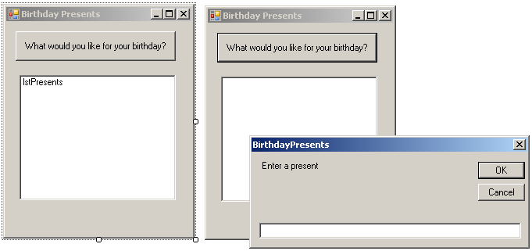
  - In the button click
    - Using a For loop to get the input for five (5) birthday presents you would like for your next birthday. Add each input to the ListBox.
  - Add a MenuStrip with a Close option that will close the application.
  - Extra Credit: Add presents until a flag is entered.
- Create a project called ConcertTickets. Add the controls shown on the form below. Name appropriately.
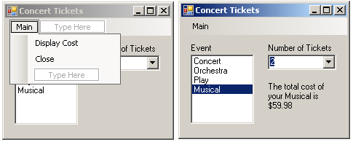
  - Add a ListBox for the event types, a ComboBox for the number of tickets and a MenuStrip.
    - Add the choices into the Items Collection for the ListBox and the ComboBox.
  - You will need variables to hold the event selected (ListBox), the number of tickets (ComboBox) and the total cost.
  - In the menu choice to display the cost.
    - Use if statements to set the values of the cost given the event selected.
If Me.lstEvent.SelectedItem = "Concert" Then
dblEventCost = 49.99
... ’complete code
    - Use an assignment statement to get the number of tickets from the ComboBox.
intNumTickets = Convert.ToInt16(Me.cboNumTickets.Text)
    - Calculate and display the total cost. Don’t forget to format your cost in your output. (.ToString(“$###.00”)
      - Concert Tickets: 49.99
      - Orchestra: 35.99
      - Play: 24.99
      - Musical: 29.99
  - In the menu choice to close the application, add the appropriate code.
  - Add a SelectedIndexChanged event for the ListBox and ComboBox to clear out the answer.
- Create a project called LunchTime. Add the controls shown on the form below. Name appropriately.
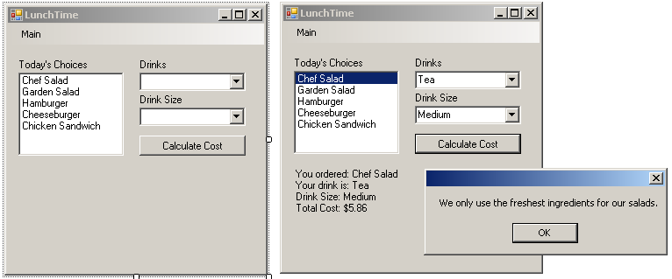
  - Add the controls shown and the items into the Items Collection.
  - In the button click, you will add the code to get the menu choice, drink choice and drink size choice.
  - Add variables for the menu choice, drink choice, drink size choice, drink cost, main cost and total cost.
    - Chef Salad, 3.99
    - Garden Salad, 2.99
    - Hamburger, 2.99
    - Cheeseburger, 3.49
    - Chicken Sandwich, 3.99
    - Small Drink, .99
    - Medium Drink, 1.49
    - Large Dring, 1.99
  - Use the following code as an example:
‘Add code to get the choices
strEntreeChoice = _________________
strDrinkChoice = _________________
strDrinkSize = __________________
‘Sets the main choice variable and the main cost variable
If Me.lstChoices.SelectedIndex = -1 Then ‘nothing selected MessageBox.Show("Please select a lunch choice") ElseIf Me.lstChoices.SelectedIndex = 0 Then dblMainCost = 3.99
. . .
continue your code.
‘sets the drink cost variable
If Me.cboDrinkSize.SelectedIndex = 0 Then
dblDrinkCost = 0.99
ElseIf Me.cboDrinkSize.SelectedIndex = 1 Then
. . .
continue your code
  - Modify your code so that is the user selects a salad a MessageBox is displayed with the following message. “We only use the freshest ingredients in our salads.”
  - Calculate the total cost adding 7% tax.
  - Display the order and cost in a label. Don’t forget to format your cost in the output.
  - Add a SelectedIndexChanged event for the ListBox and ComboBoxes to clear out the answer.

