Computer Programming 1
Essential Standard 8.01 Understand coordinate systems
Essential Standard 8.02 Apply procedures to create picture boxes using images
In all programs, put your name, the assignment name and the date in comments at the top.
Reminder, put an apostrophe (‘) in front of your line to make it a comment.
- Create a project called Shapes. Add the following controls, named appropriately.
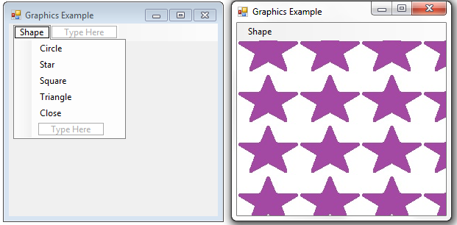
  - Add the following resources to your project.
    - blueCircle
    - purpleStar
    - redSq
    - greenTriangle
  - Clicking on a shape menu item should change the background to that shape.
To change the form’s background image:
Me.BackgroundImage = My.Resources.redSq
  - Clicking on the Close menu item should close your application.
- Create a project called StopLight. Add the following controls, named appropriately.
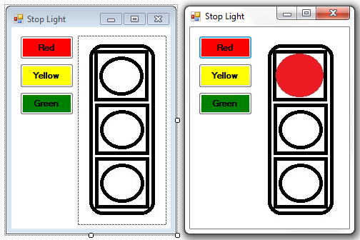
  - Add the images to the PictureBox image property.
  - For each button click, change the image in the PictureBox that represents the light color.

