Computer Programming 1
Essential Standard 5.04 Apply Decision Making Structures
In all programs, put your name, the assignment name and the date in comments at the top.
Reminder, put an apostrophe (‘) in front of your line to make it a comment.
- Open your project called ReadyForSchool. Add the controls shown below with appropriate naming.
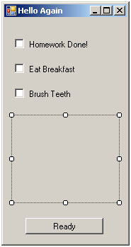
  - Modify your code to add the following.
  - Note – You many have named your variables and controls differently – use your names.
  - Create a click event for your Homework Done CheckBox. Add the statements.
If Me.chkHomework.Checked Then
MessageBox.Show(“Great Job”)
End If
  - In the Ready Button Click, add the statements.
If Not (Me.chkHomework.Checked And Me.chkBreakfast.Checked And Me.chkTeeth.Checked) Then
MessageBox.Show(“Are you sure you are ready for school”)
Else
Application.Exit()
End If
  - NOTE – Application.Exit() closes your application.
- Create a new project called Random. Add the controls shown below with appropriate naming.
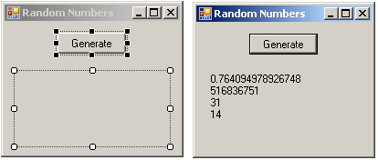
  - Declare four variables - One to hold a double value and three to hold integer values.
  - When the button is clicked, the following should occur
    - Generate a number between 0 and 1.0 (not inclusive) and set to the double variable.
    - Generate a number between 0 and 2,147,483,647 (not inclusive) and set to the first integer variable.
    - Generate a number between 0 and 100 (not inclusive) and set to the second integer variable.
    - Generate a number between 10 and 50 (not inclusive) and set to the third integer variable.
  - Display the values in one label – Use vbCrlf to show each on a separate line.
- Create a project called GuessIt. Add the controls shown below with appropriate naming. The purpose of this game is to generate a random number between 0 and 50 (not inclusive of 50) and set it to a secret number. The user then attempts to guess the secret number.
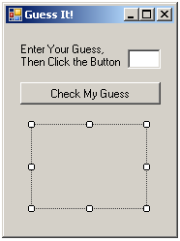
  - Declare a variable to hold the user’s guess (This will be a whole number)
  - Declare a variable to hold the secret number. Generate a random number for the value of this variable. You will want the value of this variable to hold its value (Hint).
  - Declare a counter to keep up with how many guess are tried (You will want the variable to hold its value (Hint).)
  - Get the input from the user – don’t forget to convert to an integer.
  - Add the following code to compare the guess with the secret number.
If intGuess > intGenNum Then
Me.lblMessage.Text = "Too High"
ElseIf intGuess < intGenNum Then
Me.lblMessage.Text = "Too Low"
Else
MessageBox.Show("Great Job! You Guessed it.")
Me.lblMessage.Text = "You took " & intTries
End If

Grade Range | Message to display
93 - 100 | You made an A.
85 - 92 | You made a B.
77 - 84 | You made a C.
70 - 76 | You made a D.
0 – 69 | Study More.
- Create a new project called MyGrades. Add the controls shown with appropriate names. The user will enter a numeric grade, such as an 89, and the output of “Your Grade is a B” would be displayed.
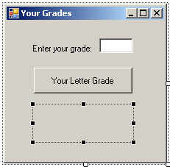
  - Create an appropriate variable to get the input.
  - Get the input from the user.
  - Use the Select…Case structure to determine what message should be displayed in the label.
- Create a new project called CellPhone. Add the controls shown with appropriate names.
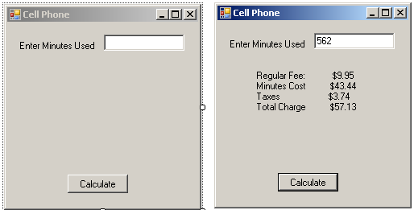
  - Use the following table to determine the monthly bill. Use a select case or If structure to come up with the minutes charge.
Minutes Used | Cost Per Minute
0 – 200 | Free
201 – 300 | .17
300 – 500 | .15
Over 500 | .12

  - In addition to the minutes charge, there is also a monthly fee of $9.95 (should be set up as a constant variable). Don’t forget to add taxes of 7%. Declare appropriate variables for all costs as well as the total cost
  - Display all costs in a label.
- Create a new project called QuickCuts. Add the controls shown below.
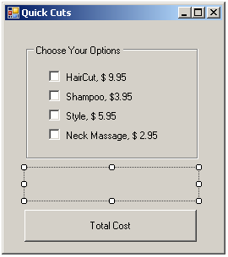
  - If the user selects an option, you should add to the total cost. If the user deselects the option, you should deduct the cost. (Use an If..Then..Else)
  - Hint: You will need to create a variable for the total cost that can be accessed by all of the CheckBox click events.
- Create a new project called SuperSize. Add the controls shown below.
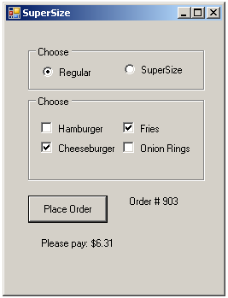
  - If the user selects a food option using the CheckBoxes, you should add to the total cost. If the user deselects the option, you should deduct the cost. (Use an If..Then..Else)
    - Hamburger – 2.95
    - Cheeseburger – 3.95
    - Fries – 1.95
    - Onion Rings – 2.50
  - If the user selects the SuperSize RadioButton, you should increase the total cost by 2.00.
  - If the user selects the Place Order button
    - You should add 7% tax, and then display the cost of the meal in the label formatted to show the dollar sign.
  - Generate a random number between 100 and 1000 to be the order number and display it in the order number label.

