Computer Programming 1
Essential Standard 4.00 Understand Variables and Naming Conventions
Challenge Exercise
You will do this program a little differently.
- Gather in your group.
- Write your algorithm. Be sure your group number and members’ names are on the document.
- On your algorithm, you do not want to write anything about design.
- Begin your algorithm with the code window. How is the entire program going to give you the answer? What are the steps you are going to write to achieve your goal? Write all the steps for creating a code.
- Once done, print out your algorithm. Use this printer:H0526-Room2611-LJ 4250.
- You will exchange the algorithm as follows:
- Group 1 – Group 2
- Group 2 – Group 3
- Group 3 – Group 4
- Group 4 – Group 5
- Group 5 – Group 6
- Group 6- Group 7
- Group 7 – Group 8
- Group 8 -- Group 1

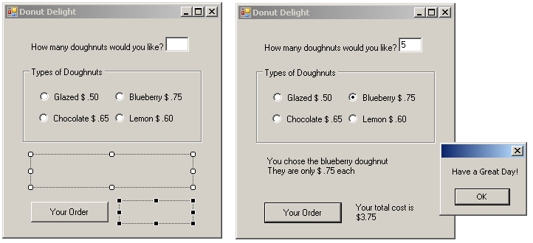
Create a new project called donutDelight.
- Add the controls shown on the design image above.
- Declare variables for the price of a doughnut and for the quantity.
  - The price of the doughnut will be set in each RadioButton CheckChanged event, so declare the price variable globally. This way you can use the price variable in the button click.
- Create RadioButton CheckChanged events
  - Display an appropriate message and the cost of that type of doughnut on separate lines.
  - Set the price variable equal to the appropriate price.
- In the button click
  - Display the total cost in the second label
    - Your cost should be formatted.
  - Display a MessageBox with the shown message.

