Computer Programming 1
Essential Standard 6.02 Apply Procedures to Develop Message, Input, and Dialog Boxes
Programming Exercises
In all programs, put your name, the assignment name and the date in comments at the top.
Reminder, put an apostrophe (‘) in front of your line to make it a comment.
- Open Bands
  - In the Beatles button click, add the following code to ask the user a question and evaluate the Yes/No response.
If MessageBox.Show("Do you like the Beatles?", "Beatles Survey", MessageBoxButtons.YesNo) = Windows.Forms.DialogResult.Yes Then
MessageBox.Show("The Beatles are awesome.")
Else
MessageBox.Show("Maybe you've never heard of The Beatles?")
End If
  - Add similar messages for the remaining bands.
  - Add a dialog box (Windows form).
  - Add a label to the dialog box that displays the following message.
“These are just a few classic rock bands that helped to shape rock and roll music.”
  - Add a Close button to the dialog box form
    - Create a button click that will close the form.
  - On your main Bands form,
    - Add a new menu item called About.
    - Create a click event for the item.
      - Add the code to open the dialog box you have created.
- Open BirthdayPresents.
  - In the button click
    - Using an If statement with a MessageBox, ask the question “Do you have a favorite restaurant you like to go to on your birthday?”. If the answer is yes, display an InputBox to get the name of the restaurant.
    - Use another MessageBox to display the name of the restaurant.
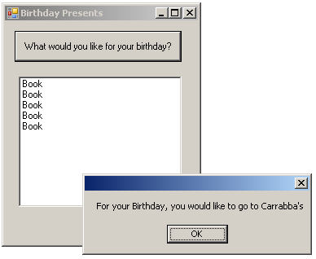
- Create a project called WorldWar2.
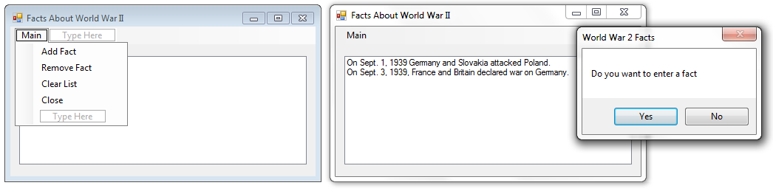
  - Add a MenuString with the above items. Add an empty ListBox.
  - Add Facts Menu Item
    - Use a For Loop to prompt for five facts about World War 2.
      - Use an InputBox to get a fact (set to a string variable).
      - Add the fact to the ListBox.
  - Remove Facts Menu Item
    - Use an InputBox to get a fact (set to a string variable) to remove.
    - Remove the fact from the ListBox.
  - Clear List Menu Item - Use the statement to clear all items.
  - Close Menu Item - Close the application.
  - EXTRA CREDIT – extra 5 points
    - Use a Do While Loop to prompt for as many facts as the user wants to add.
      - Create a Boolean variable to hold when to continue (flag)
      - Use an If statement with a MessageBox with Yes/No buttons to determine if the user wants to enter a fact.
        - If yes, prompt for the fact (InputBox) and add it to the ListBox.
        - If not, set Boolean flag variable to false.
  - Where to get your facts?
    - http://www.history.com/topics/world-war-ii
    - http://www.digitalhistory.uh.edu/modules/ww2/index.cfm
    - http://www.wwiimemorial.com/
    - Use the Internet to search for more.

