Computer Programming 1
Essential Standard 7.02 Apply One-Dimensional Arrays
In all programs, put your name, the assignment name and the date in comments at the top.
Walk-Through Exercises
- Create a project called friendsArray. The purpose of this program will be to add 5 names to the array using InputBoxes, then display those names in a label, sorted ascending.
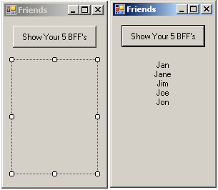
  - In the button click, add the following code:
Dim FriendArr(4) As String 'declare the array - size 5

'Loop to add strings from InputBoxes to the array
For i As Integer = 0 To FriendArr.Length - 1
FriendArr(i) = InputBox("Enter a friend's name.", "BFF")
Next i

'Sort the array, ascending
Array.Sort(FriendArr)

'Loop to add the values from the array to the label using
‘concatenation
For i As Integer = 0 To FriendArr.Length - 1
Me.lblDisplay.Text &= FriendArr(i) & vbCrLf
Next i

- Create a project called favoriteFoods. The purpose of this program is to add a list of your five favorite foods to an array, then display them sorted ascending. Create subs to add your values and display your values.
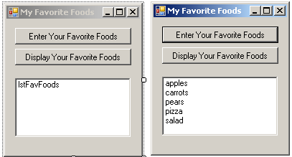
  - Add the array declaration globally
Dim strFoodsArr(4) As String
  - Add the following to create the sub to add values.
Private Sub enterFoods(ByRef strFoodsArr() As String)
'Add string values to the array
For i As Integer = 0 To strFoodsArr.Length - 1
strFoodsArr(i) = InputBox("Enter one of your favorite
foods", "My Favorite Foods")
Next i
End Sub
  - Add the following to create the sub to display the values.
Private Sub showFoods(ByVal strFoodsArr() As String)
Array.Sort(strFoodsArr)
For i As Integer = 0 To strFoodsArr.Length - 1
Me.lstFavFoods.Items.Add(strFoodsArr(i))
Next i
End Sub
  - Add the following code to your enter button click.
enterFoods(strFoodsArr)

  - Add the following code to your show button click.
showFoods(strFoodsArr)
- Create a project called testData. The purpose of this program will be to create parallel arrays to hold student names and student test grades.
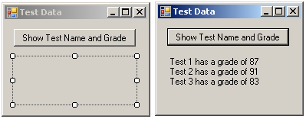
  - Add the following code to your button click.
‘Create the parallel arrays and initialize them
Dim testNameArr() As String = {"Test 1", "Test 2", "Test 3"}
Dim testGradeArr() As Integer = {87, 91, 83}
‘Loop to add the values from the arrays to the text in the label
For i As Integer = 0 To 2
Me.lblDisplay.Text &= testNameArr(i) & " has a grade of " & testGradeArr(i) & vbCrLf
Next i
- Create a project called numArray. The purpose of this program will be to add 3 numbers to an array and find their average. Use Subs to add the numbers to the array.
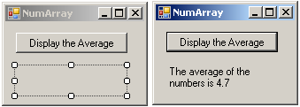
  - Create the Sub to Add the Numbers to the Array.
‘Sub to add values to the array
Private Sub addToArray(ByRef intNumArr() As Integer)
For i As Integer = 0 To intNumArr.Length - 1
intNumArr(i) = InputBox("Enter a Number")
Next i
End Sub
  - Create the function to get the average of the numbers in the array.
‘Function to determine and return the average given the array.
Function getAverage(ByVal intNumArr() As Integer) As Double
Dim sum, avg As Double
For Each num As Integer In intNumArr
sum += num
Next
avg = sum / intNumArr.Length
Return avg
End Function

  - Add the following code in the button click to populate the array by calling the sub, and then call the function to set the value for the average and display the average in the label.
Dim intNumArr(2) As Integer
Dim average As Double
addToArray(intNumArr)
average = getAverage(intNumArr)
Me.lblDisplayAvg.Text = "The average of the numbers is " &
average.ToString("##.0")

