Computer Programming 1
Essential Standard 4.00 Understand Variables and Naming Conventions
In all programs, put your name, the assignment name and the date in comments at the top.
Reminder, put an apostrophe (‘) in front of your line to make it a comment.
- Create a new project called HelloAgain
  - Add the controls shown on the form below. Name them appropriately
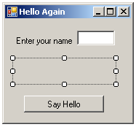

  - Create a variable for the input name.
  - Display the following message when the button is clicked.
Hello, Your Name
- Create a new project called Grades
  - Add the following controls
Control | Name Property | Text Property
Form | You may leave it Form1 | Grades
Label | lblGrades | Empty
Label | lblQ1Prompt | Enter your Quarter 1 Average
Label | lblQ2Prompt | Enter your Quarter 2 Average
Label | lblFEPrompt | Enter your final exam grade
TextBox | txtQ1Grade
TextBox | txtQ2Grade
TextBox | txtFEGrade
Button | btnShowGrade | Your Grade
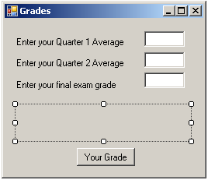

- For the btnShowGrade control, create a Click event.
    - Declare variables for the quarter 1 average, quarter 2 average and the final exam average. (These are your input variables)
    - Declare a variable for your final grade. (This is your output variable)
    - Get the input from your textboxes
      - Example:
Dim intQ1 As Integer
intQ1 = txtQ1Grade.Text
    - Calculate the final grade using the following formula
grade = ( .4 * q1grade) + (.4 * q2grade) + (.2 * finalExam)
    - Display the grade in your label.
- Create a new project called Pizza2
Control | Name Property | Text Property
Form | You may leave it Form1 | Pizza2
Label | lblOrder | Empty
Label | lblCrustPrompt | Enter your choice of crust (thin, thick, regular)
Label | lblTopping1Prompt | Enter your choice of topping
Label | lblTopping2Prompt | Enter your choice of topping
TextBox | txtCrust
TextBox | txtTopping2
TextBox | txtTopping3
Button | btnYourOrder | Your Order
  - Add the following controls
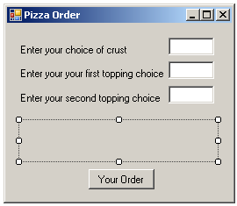
  - Use the input from the textboxes to get the user’s input.
  - Display the choices in the label.
  - Create TextChanged events to clear the label.
- Create a new project called circleArea that prompts the user for a radius, calculates the area of the circle and displays the answer. Declare the appropriate variables for input and output and include a TextChanged event to clear the answer. Declare pi as a constant variable (Const dblPI As Double = 3.1457). Use the formula area = PI * r * r.
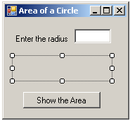
- Open the HelloAgain project. Remove the label and display your “Hello yourName” message in a MessageBox.
- Create a project called ReadyForSchool. Add the controls shown below, naming them appropriately.
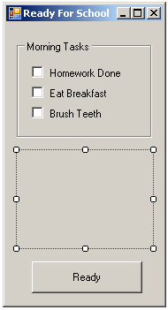
  - Create a CheckChanged event for the Homework Done! CheckBox that displays a MessageBox that says “Good Job!” when that CheckBox is done.
  - As the CheckBoxes are checked, add their messages to the label. Make sure you are using concatenation (&=) with the label.Text so that the message add. Remember you can go to a new line with vbCrlf.
Example:
lblMessage.Text &= “Message here” & vbCrlf
  - When the Button is clicked, the label should display the message “Ready for School”
- Create a project called Scope. Create a global variable called x, set to 10. Create two buttons as shown.
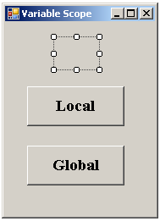
  - In the Local button click, declare a variable called x, set to 5. Display the value of x in the label. When clicked, 5 should be displayed in the label.
lblScopeAnswer.Text = x
  - In the Global button click, display the value of x in the label. When clicked, 10 should be displayed in the label.
lblScopeAnswer.Text = x
- Create a project called Counting. Create two buttons as shown.
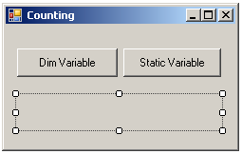
  - In the Dim Variable button click
    - Declare a variable called intCounter and initialize it to 1.
    - Add the statement below which will add 1 to your variable
intCounter = intCounter + 1
  - In the Static Variable button click
    - Declare a variable called intCounter and initialize it to 1.
    - Add the statement below which will add 1 to your variable
intCounter = intCounter + 1
  - When the buttons are clicked, the variable should be displayed in the label.
  - Run your program and note how the Static variable changes as it holds its value.

