Computer Programming 1
Essential Standard 7.00 Apply Advanced Logic
7.01 Apply sub procedures/methods and user defined functions.
In all programs, put your name, the assignment name and the date in comments at the top.
Programming Exercises
- Create a project called Reasons. Add the controls shown below with appropriate naming.
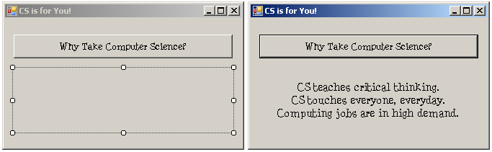
  - When the button is clicked, a showReasons() sub should be called.
  - The showReasons() sub should display the text shown above.
- Open your GuessIt project from 6.02.
  - Create a Hint() procedure that compares the guess and the actual number and displays a hint of “Too high”, “Too low” or “Great Job – You guessed it!”.
- Create a project called Candy. Add the controls shown below with appropriate naming.
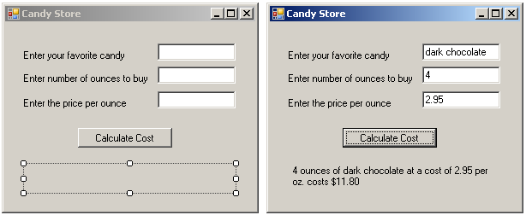
  - Use Try…Catch to get input for the variables.
  - When the button is clicked, a Calculate sub should be called. All of the values should be sent to the sub.
  - The Calculate sub should calculate the total cost and display the answer as shown.
- Create a project called shakespeareanInsults. Add the controls shown below with appropriate naming. The program will randomly generate a Shakespearean insult shown in the label.
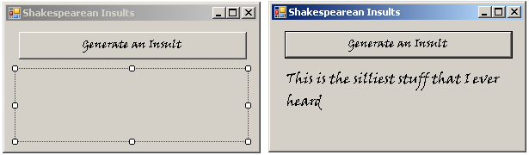
  - In the button click, you will need to generate a random number between 1 & 5 that will be passed to the showInsult() procedure. After the call, the insult should be displayed in the label in the button click.
  - The showInsult() procedure should have two parameters: a value parameter to send the random number and a reference string parameter to set the insult. In the sub procedure, use a decision statement to determine which “insult” is set to the string variable.
  - Insults:
"I think he be transformed into a beast; for I can nowhere find him like a man” ~ As You Like It
"Lets meet as little as we can" ~ As You Like It
"I desire that we be better strangers" ~ As You Like It
"Boys, apes, braggarts, jacks, milksops!" ~ Much Ado About Nothing
"This is the silliest stuff that I ever heard" ~ A Midsummer Night's Dream
- Create a project called sortNums. Add the controls shown below with appropriate naming.
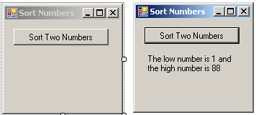
  - In the button click, get two numbers using InputBoxes .
  - The program should include a sortNum() procedure with two reference parameters that will sort the numbers.
  - Hint on sorting:
If intNum1 > intNum2 Then
intTemp = intNum1
intNum1 = intNum2
intNum2 = intTemp
End If
- Create a project called footballGame. Add the controls shown below with appropriate naming.
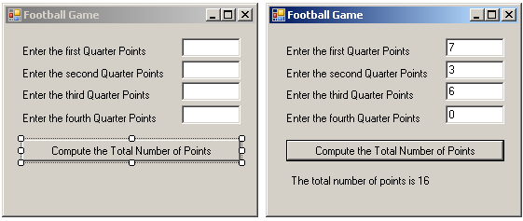
  - Use try…catch to get input from the textboxes.
  - Create a calcTotal() function that will receive all four quarter scores and return the total score.
  - Display the score in the label.
- Create a project called Savings. Add the controls shown below with appropriate naming.
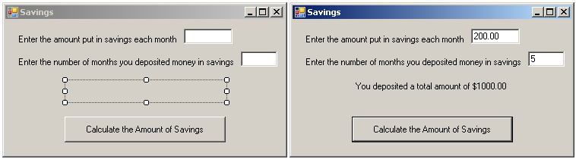
  - Use try…catch to get input from the textboxes.
  - The project should have a calcDeposit function that returns the total amount deposited.
  - Display the amount in the label.

