# File Submittal Instructions for Programming Exercises

***You will submit two files for each project: the “Form1.vb” file and the “.exe” file.***

If you are not saving files to a specific location, then Visual Studio has probably saved them to the following default location:

**The file folder located at the top left of your Desktop screen. *Note that it will most likely have your student ID number there rather than your name.***

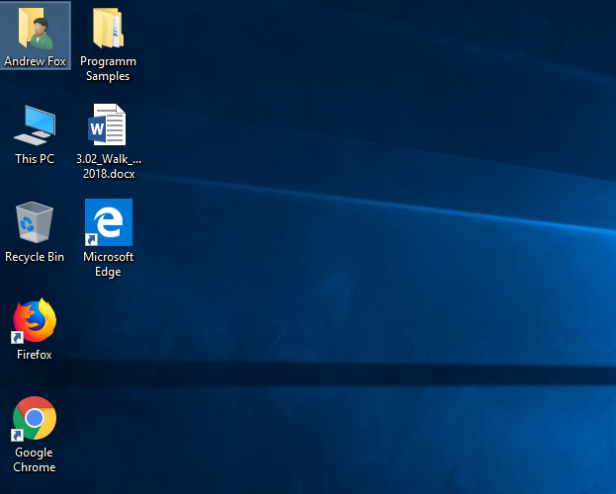

**Go to the “Source” folder.**

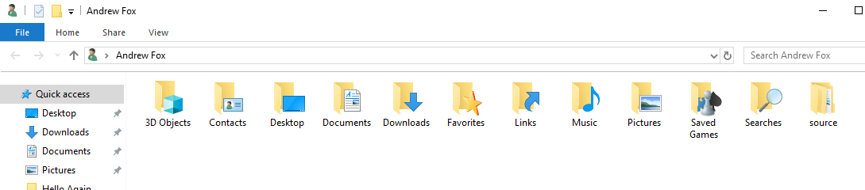

**Go to the “repos” folder.**

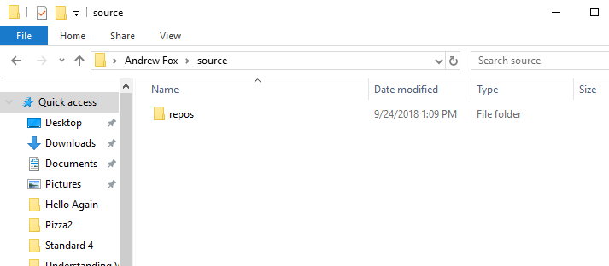

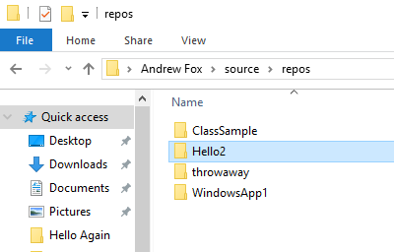

**Select the appropriate project folder.**

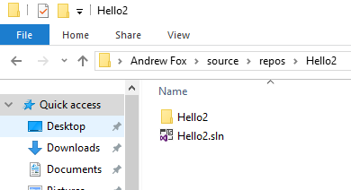

**Go into the next subfolder.**

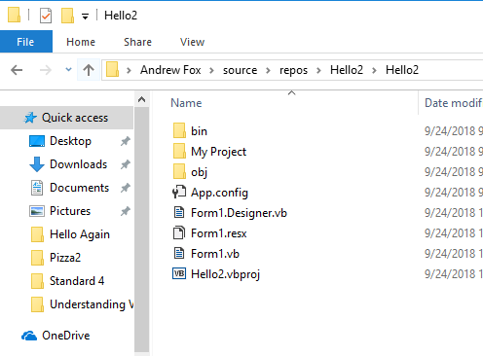

**The “Form1.vb” file is located here.**



**For the .exe file, go into the “bin” folder.**

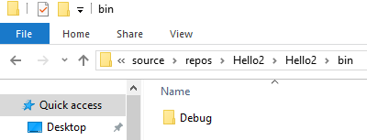

**Then, go into the “debug” folder.**

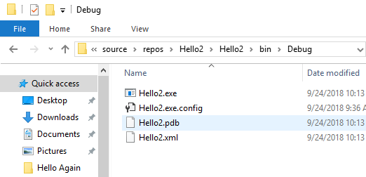

**The “.exe” file is located here.**