Computer Programming 1
Essential Standard 3.00 Apply Procedures to Construct Windows Forms
- Create a new project called Games
  - Add the following controls
Control | Name Property | Text Property
Form | You may leave it Form1 | Video Games
Button | btnGame1 | Add the name of a video game.
Button | btnGame2 | Add the name of a video game.
Button | btnGame3 | Add the name of a video game.
Button | btnGame4 | Add the name of a video game.
Label | lblGameInfo | Empty
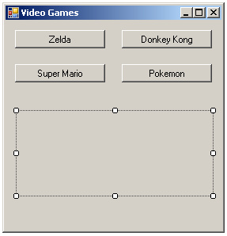

- For each Button control, create a Click event.
- btnGame1 Click Event
    - Add the text to your lblGameInfo
      - Example: lblGameInfo.Text = “The Legend of Zelda is a fantasy action-adventure game.”
  - btnGame2 Click Event
    - Add the text to your lblGameInfo
  - btnGame3 Click Event
    - Add the text to your lblGameInfo
  - btnGame4Click Event
    - Add the text to your lblGameInfo

- Create a new project called Pizza
  - Add the following controls
Control | Name Property | Text Property
Form | You may leave it Form1 | Your Pizza
Label | lblChoice1 | Empty
Label | lblChoice2 | Empty
Label | lblChoice3 | Empty
GroupBox | grpChoices | Your Choices
CheckBox | chkPepperoni | Pepperoni
CheckBox | chkCheese | Cheese
CheckBox | chkMushrooms | Mushrooms
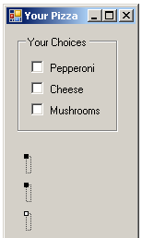

  - For each CheckBox control, create a Click event.
  - chkPepperoni Click Event
    - Add the following text to your lblChoice1: “You chose to add pepperoni.”
  - chkCheese Click Event
    - Add the following text to your lblChoice2: “You chose to add cheese.”
  - chkMushrooms Click Event
    - Add the following text to your lblChoice3: “You chose to add mushrooms.”
  - Run and test your program.

- Create a new project called Cookies
  - Add the following controls
Control | Name Property | Text Property
Form | You may leave it Form1 | Cookie Shop
Button | btnOrder | Order
Label | lblChoice | Empty
GroupBox | grpChoices | Your Choices
RadioButton | radChocChip | Chocolate Chip
RadioButton | radOatmeal | Oatmeal Raisin
RadioButton | radPeanutButter | Peanut Butter
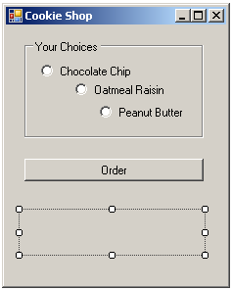

  - For each RadioButton control, create a Click event.
  - radChocChip Click Event
    - Add the following text to your lblChoice: “You chose our chocolate chip cookies.”
  - radOatmeal Click Event
    - Add the following text to your lblChoice: “You chose our oatmeal raisin cookies.”
  - radPeanutButter Click Event
    - Add the following text to your lblChoice: “You chose our peanut butter cookies.”
  - btnOrder Click Event
    - Add the following text to your lblChoice: “Order MORE Cookies.”
  - Run and test your program.

- Create a Project called Sandwich
  - Add the following controls
Control | Name Property | Text Property
Form | You may leave it Form1 | Sandwich Shop
Label | lblMainChoice | Empty
Label | lblChoice1 | Empty
Label | lblChoice2 | Empty
Label | lblChoice3 | Empty
GroupBox | grpMain | Main Choice
RadioButton | radHam | Ham
RadioButton | radTurkey | Turkey
GroupBox | grpChoices | Condiments
CheckBox | chkMayo | Mayonnaise
CheckBox | chkMustard | Mustard
CheckBox | chkCheese | Cheese
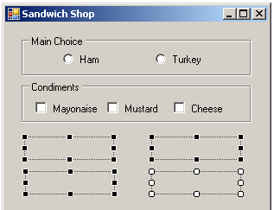

  - For each control, create a Click event.
  - radHam Click Event
    - Add the following text to your lblMainChoice: “You chose the ham sandwich.”
  - radTurkey Click Event
    - Add the following text to your lblMainChoice: “You chose the turkey sandwich.”
  - chkMayo Click Event
    - Add the following text to your lblChoice1: “You would like mayonnaise.”
  - chkMustard Click Event
    - Add the following text to your lblChoice2: “You would like mustard.”
  - chkCheese Click Event
    - Add the following text to your lblChoice3: “You would like cheese.”
  - Run and test your program.

- Create a project called Bikes.
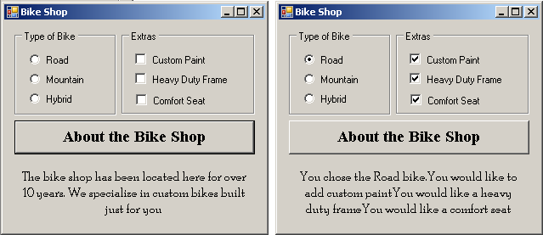

  - Add the controls seen in the example above.
    - Make certain you name them properly.
  - Add the button click event that will display the text for “About the Bike Shop”
  - Add the CheckChanged event for the RadioButtons and the CheckBoxes.
    - Display appropriate text in the label.
    - Make certain you have your text add to the existing text in the label.

